P65Pas 0. 8. 9

Documentation – Fundamentals and Analysis

By Tito Hinostroza

Content

REFERENCES5
1INTRODUCTION6
1.1Resummary6
1.2Complete constructor6
1.3Implementation9
2The LANGUAGE11
2.1Differences with the Pascal language11
2.2Blocks11
2.3Sentencies12
2.3.1sntAssigment 12
2.3.2sntExpres 12
2.4Operand 13
2.5Expressions13
2.6Operandos13
2.7Structural locks14
3SYNTAX ELEMENTS15
3.1Declaration elements16
3.2Structure elements17
3.3Items of expression18
3.4Elements relating to instructions18
4CONSTANTS19
4.1Contention declarations19
4.1.1Structured components21
4.1.2Interstate assessment22
4.2Life cycle of constants23
4.3Constant expressions24
5TYPE HANDLING26
5.1The TEleTypeDec26 class
5.2Basic Types27
5.3Type categories29
5.4User-defined types30
5.5 Copy Types31
6 BASIC AND STRUCTURED TYPES32
6.1 Boolean type32
6.2AcumStatInZ33 flag
6.3Structured Types35
7EXPRESSIONS36
7.1 Pascal Expressions36
7.2Expressions in P65Pas36
7.3Operators and precedence38
7.4Objects and Methods40
7.5Special operators41
7.6Functions in expressions43
7.7Diagrams in tree44
7.8Operations and expressions46
7.9Assignments47
8FUNCTIONS AND PROCEDURES48
8.1Procedures and functions48
8.2Representation of functions48
8.3The problem of declaration/implementation calls50
8.4Functions as object methods. 51
8.5User and System Functions52
8.5.1System Functions52
8.5.2User Functions53
8.6Complication of functions for operators53
10SYNTAX TREES56
10.1Foundamentos56
10.2Structure58
10.3Duplicity of names60
10.4Name Resolution61
10.4.1FindFirst() y FindNext() 61
10.4.2Comparison of Identifiers64
10.4.3Diprooting64
10.4.4Calls from TEleBody65
10.4.5Calls from declarations66
10.5Filling the syntax tree67
10.5.1 Considerations67
10.6Calls or References68
10.6.1Calls from TEleConsDec69
10.6.2Calls from TEleVarDec70
10.6.3Calls from TEleTypeDec70
10.6.4Calls from TEleBody70
10.6.5Call Deployment71
10.6.6Code containers72
10.6.7 "Callers" and "called". 74
10.6.8Called elements75
10.7Program Frames76
10.8Syntax blocks77
10.9Final state of the AST78
11SENTENENCES80
11.1Types of sentences80
11.2Process Call Answers81
11.3Assignment Factors81
11.3.1Expressions83
11.4Assembly Locks83
11.5Conditional83
11.5.1Structure of a conditional85
12ASSEMBLY LOCKS87
12.1Lexicon analyzer87
12.2AsM88 Instruction Types
12.3Common Instructions89
12.3.1Direct operations89
12.3.2Operandos element91
12.3.3Operandos tag91
12.3.4Operating "$" 94
12.3.5Operations94
12.4Tagged Instructions96

REFERENCES

For a better understanding of this documentation, it is recommended to have knowledge of the following topics:

- Object Pascal
- Library P65Utils.
- CPU 6502.
- Assembly language of the 6502.

INTRODUCTION

Summary

The P65Pas project is an extensive project like any project that aims to develop a functional compiler of a high-level language like Pascal.

The project consists of the development of a cross-platform Pascal compiler, which compiles binary code for the CPU6502, without external dependencies.

The project, including all the libraries used, is developed using the Lazarus IDE, with the Free Pascal compiler.

This project was born as an extension of the PicPas project, a compiler for PIC microcontrollers, but that has taken a separate course and that has allowed the author to test new designs in terms of the internal structure of the compiler. In other words, this compiler was born from the PicPas compiler but uses new design techniques to improve the functionalities of the compiler and fix bugs found in the development of PicPas.

The main objectives of this project were:

- Reuse all the engineering developed for the PicPas compiler, in a new compiler project.
- Test the libraries developed (of my authorship) in a new project so that they are improved and become more general.
- Provide a functional compiler as an alternative to development on the CPU 6502, using the Pascal language.
- Test new compiler design techniques in a new project, with little risk, because it is a new project.

While this compiler is intended to be considered a Pascal compiler, the implementation of the Pascal language is different from the ISO implementation or those of Turbo/Borland Pascal. For more information on the differences, see Section 2.1.

Compiler Structure

You could say that the compiler follows the more or less standard design of most compilers.

In summary, you could divide the compiler into three main processes:

The intermediate representation is the abstract syntax tree. Here the product of the analysis is written and it is also the workspace for optimization.

One point where P65Pas differs from classical compilers could be in the fact that syntactic analysis is minimal and is very strongly attached to the semantic parser. That is, a pure syntactic analysis is not performed, but it is done while doing the same semantic analysis of the language.

By not having a separate stage of syntactic analysis, it becomes difficult for the compiler to generate multiple errors in the same source code, since for this it would be necessary to jump to a next statement, when it is detected that the current statement has errors, and for this it would be necessary to identify the sentences first (pure syntactic analysis)..

The compiler, on a global level, is seen as a class, more or less extensive that is built as a cascade of various classes that scale in a nested inheritance relationship.

In a class diagram, we would see that the compiler follows the following structure:

TContext
TCompilerBase
TCompMain
TParserDirecBase

TGenCodBas

TGenCod

TParserDirec

TCompiler_PIC16

Implementation

The drives (files) that define the compiler, in hierarchy, are:
Lexical Analyzer
CompContexts
LexPas

CompBase
CPU architecture independent units

CompMain

ParserDirec

GenCodBas_PIC16
GenCod_PIC16

They constitute the code generator.

ParserAsm_PIC16

P65Utils
Policy Processing
ParserDirec_PIC16
Compiler_PIC16

The innermost drives—CompContexts, CompBase, CompMain, and ParserDirec—are designed not to be unique to the P6502 compiler, but can serve as the basis for other compilers or interpreters (as, in fact, is done in the P65Pas project) and contain the routines of the lexical parser, parser parser , the definition of the TCompilerBase compiler object, and most of the directive processor.

The outermost drives, which make use of the P65Utils library, are specific to the CPU6502, and implement code generation, and assembly functions (for ASM blocks). In addition, they contain the highest-level routines, such as those that perform unit compilation and binding.

This separation of units, into dependent and non-CPU dependent, although it may not seem very useful in this compiler (except for the modular theme), if it is important if you plan to reuse code for other compilers. An example of this is best seen in the PicPas compiler, which includes 3 different compilers using the same base units.

LANGUAGE

For the implementation of the compiler, we start from the definition of the syntax of the Pascal language, in the way it will be implemented in this compiler.

The particular implementation of Pascal, which is done in this compiler, is simplified (to work with devices of limited resources), but in addition this implementation contains modern features such as basic support for objects.

For the generation of the diagrams, the tool is being used: https://tabatkins.github.io/railroad-diagrams/

Differences with the Pascal language

The implementation of Pascal, which defines the compiler, differs from the Pascal language, which most compilers use, mainly in:

- The syntax of the IF and WHILE blocks correspond to the way they are defined in Modula-2. That is, they do not generate BEGIN blocks ... END.
- Only simple types are implemented, such as Char, Boolean, Byte, and Word. The string type is also not implemented.
- The syntax is attached to OOP notation, rather than Pascal's typical structured programming. So instead of using "length(a)", it is preferred to use "a.length".
- Almost all data types, including basic types such as Byte or Boolean, include methods that can be called in the common form of OOP: <variable>.<method>
- There are no operators, in the strict sense. Operators, within this language, are just shorthand ways of calling methods. For example, the expression "x+y" can be written as "x._add(y)". For more information on handling expressions see section 10.2.3.

Blocks

The recognized blocks are:

CONST
TYPE
WHERE
PROCEDURE
FUNCTION (Pascal mode only)
BEGIN

Note that unlike standard Pascal, LABEL tag blocks are not recognized.

The BEGIN blocks... END, are recognized as a set of sentences.

Sentences

The various types of statements are determined with the enumerated TxpSentence, defined in the XpresAST unit.

The recognized judgments are:

sntAssigment
Simple assignment statement:
Diagram(Sequence(NonTerminal('variable'),Terminal(':='),NonTerminal('Expression'))

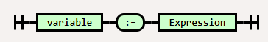

sntExpres
Expression, or operand.
Diagram(
NonTerminal('procedure identifier'),
Choice(1,
Skip(),
Sequence(Terminal('('), OneOrMore(NonTerminal('expression'),','), Terminal(')')
),
)
)

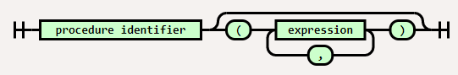

This case also includes functions.

sntBEGIN… END
sntIF
sntREPEAT
sntWHILE
sntFOR
sntCASE

Operand

Expressions

Expressions are defined a little differently than common Pascal compilers:

Operands

They are considered as expressions with the greatest precedence. That is, indivisible.

They are classified into:

Constant -> It can be literal or constant expression.
Variable
FunOperand
Brackets -> Expression in parentheses.

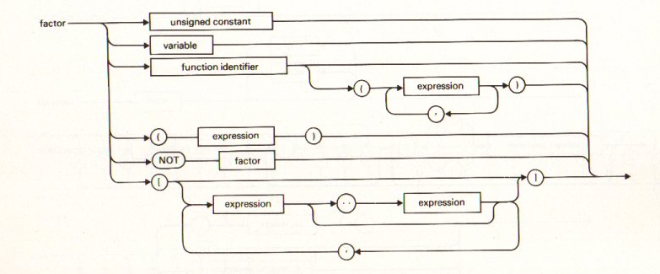

Structural blocks

This section describes how the compiler processes the structural blocks of a program.

These blocks are:

Programmes
Declarations
Main body
Units
Interface section
Implementation Section
Initialization Section
Completion Section

A program

Sentences

The sentences are of the following type:

Common judgments.
Assembler blocks

SYNTAX ELEMENTS

To perform the analysis of a source code, the compiler models to:

- Expressions
- Variables
- Constant
- Procedures
- etc.,

as objects called "elements" (as a short form of "syntax elements" or "elements of a program") and this is how they are identified within the compiler source code.

Elements are objects that derive from the TxpElement class, declared in the XpresElemP65 unit:

{ TxpElement }
//Base class for all syntactic elements
TxpElement = class
private
Fname : string; //Element name
Funame : string; //Upper case name. Used to acelerate searchings.
procedure Setname(AValue: string);
public //Callers management
lstCallers: TxpListCallers;
function nCalled: integer; virtual;
function IsCalledBy(callElem: TxpElement): boolean;
function IsCalledByChildOf(callElem: TxpElement): boolean;
function IsCalledAt(callPos: TSrcPos): boolean;
function IsDeclaredAt(decPos: TSrcPos): boolean;
...
public //Location in the source code.
srcDec: TSrcPos; //Where the element starts.
srcEnd: TSrcPos; //Where the element ends.
...

The attributes of this class represent the common properties that elements must have. Thus, for example, all elements such as variables, constants or the body of the main program itself, have a location in the source code, where it is declared or implemented. This location must be saved in the "srcDec" field.

From this class, it is that the various elements of the program are derived, adding the fields and methods that each element requires.

Since all element classes have a common ancestor, to identify specialized classes, a numeric identifier is used that is initialized in the constructor of each specialized class:

constructor TEleVarDec.Create;
begin
inherited;
idClass := eleVarDec;
end;

Classes derived from TxpElement, are recognized by their identifier, instead of using the RTTI options (to identify classes) of Free Pascal, to gain efficiency.

Listed below are the various types of items that are handled in the current version (Declared on the XpresElemP65 drive):

//Element types for the language.
TxpIDClass = (//Declaraction
eleNone, //No type
eleVarDec, //Variable declaration
eleConsDec, //Constant declaration
eleType, //Type declaration
eleFuncDec, //Function declaration
eleFunc, //Function
//Structural
eleProgFrame, //Code container
eleProg, //Main program
eleUnit, //Unit
eleBody, //Body procedure/program
eleBlock, //Block of code
eleFinal, //FINALIZATION section
//Instructions relative
eleSenten, //Sentence/Instruction
eleAsmInstr, //ASM line
eleAsmBlk, //ASM block
eleCondit, //Condition
//Of Expressions
eleExpress, //Expression
eleAsmOperand,//Operand
eleAsmOperat //Operator
);

TxpELement objects are important because they are precisely the objects that are added to the syntax tree (See section 10) and that are, precisely, the nodes.

Elements of declaration

These elements are created from the declaration sections of programs, functions, or units.

Identifier | Class | Description
eleNone | TxpElement | It is an element that has not yet been specialized with a type.
eleVarDec | TEleVarDec | They represent a variable, local or global. Includes objects.
eleConsDec | TEleConsDec | They represent a local, or global, constant. Includes objects.
eleType | TEleTypeDec | Represents a type declaration.
eleFuncDec | TEleFunDec | They represent the declaration of a function or procedure.
eleFunc | TEleFun | They represent the implementation of a function or procedure.

These elements are reflected graphically in the code explorer, before the body of a program, function or unit:

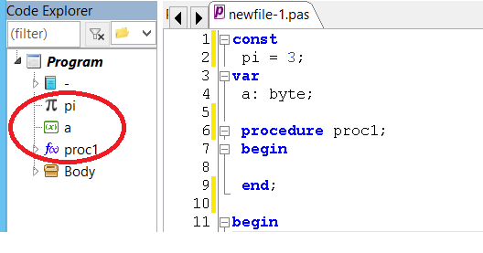

Structure elements

These elements represent the broader blocks that define the structure of the programs.

Identifier | Class | Description
eleBody | TEleBody | It represents the main body of the program, seen as a single block. It does not include statements. It also represents the body of the procedures and the INITIALIZATION section of the units.
eleBlock | TEleBlock | Represents a block of code as the body of an IF or a section delimited by BEGIN... END.
eleProgFrame | TEleProgFrame | They represent a program, unit, or function. For more information see Section 9.8
eleProg | TEleProg | It is the main node of the syntax tree, and therefore contains all the elements of the syntax tree.
eleUnit | TEleUnit | They represent the ID of a unit in the USES section.
eleFinal | TEleFinal | Represents the FINALIZATION section of the units.

There is an additional element: TxpEleDIREC that is used to represent conditional nodes in the policy tree. TxpEleDIREC elements are not stored in the main syntax tree.

Expression elements

Expression elements represent all the elements commonly found in a Pascal expression, such as operands and methods.

Identifier | Class | Description
eleExpress | TEleExpress | Represent an expression or operand. For more information see Section 9
eleAsmOperat | TEleAsmOperat | Represents an operator within ASM blocks.

The eleAsmOperand and eleAsmOperat types are reserved exclusively for handling ASM blocks, which handle expressions in the classical sense, unlike how they are handled in the Pascal of the P65Pas (See Section 7.2).

Within the compiler (excluding ASM blocks) expressions, of any kind, will be represented by an element of the TeleExpress class, and will have the same shape as the diagrams shown in section 8.7.

For more information on the representation of expressions within the Syntax Tree, see section 9.3,

Elements relating to instructions

These elements model statements or instructions.

Identifier | Class | Description
eleSenten | TxpEleSentence | They represent a sentence.
eleAsmInstr | TEleAsmInstr | Represents an assemblyman statement within asM blocks.
eleAsmBlock | TEleAsmBlock | Represents an ASM block. Delimited by ASM ... END

Statements are all instructions that a program can contain, including ASM blocks. For more information on sentencing, see Section 11.

CONSTANT

Semantically we understand Constants as values that, once declared and initialized, do not change during the course of the entire program.

The declaration of a constant is made in the form:

Const
CONST1 = 2; //Declaration of a constant
...

And to reference a constant, it is enough to use its name:

...
X := CONST1; //Reference to a constant
...

Syntactically constant declarations and constant references generate different elements in the Syntax Tree:

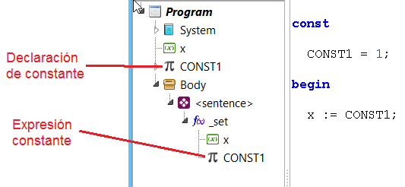

Therefore, we will study two completely different types of elements:

- Constant statements
- Constant expressions

Constant statements

Constant declarations appear at the beginning of a program:

sample program;
Const
CONST1 = 2; //Declaration of a constant
CONST2 = CONST1 + 3; //Reference to another constant
...

You can verify that these declarations generate syntax elements by viewing the code explorer:

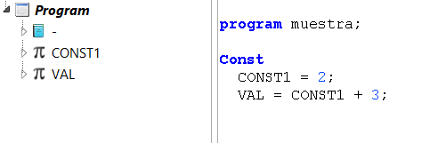

The "constant declaration" elements are modeled with the TEleConsDec class, which derives from the TxpEleCodeCont class that defines code containers (For more information on code containers, see section 10.8.6).

The actual value of the constants is saved in the "value" field of TEleConsDec, which is an object that allows you to store values of all data types supported by the compiler.

TEleConsDec = class(TxpEleCodeCont)
//Element type
type: TEleTypeDec;
evaluated: boolean;
//Constant value
value : TConsValue;
constructor Create; override;
end;

The TEleConsDec elements represent the constants in the declarations section, but do not represent the constants when referenced from the statements (There the TxpEleExpres element is used).

Literals such as 123, $FF or 'A' are also constant from the syntactic point of view, but are not modeled as a TxpEleCodeCont object, within the compiler. These literals are read the moment they are found and loaded into a TEleExpress, assigning the value to it and setting them to the otConst type.

Constants can also contain expressions in their definition. In the analysis process, the expressions are included within the constant elements:

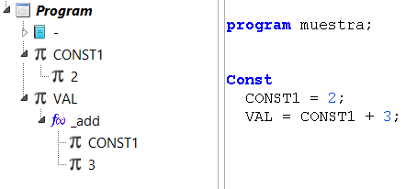

Structured constants

Constant declarations could be initialized with complex values such as arrays, pointers, or objects.

Consider for example the following case:

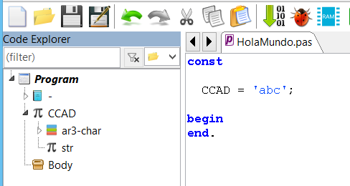

This constant statement is initialized with a string that within the language, is interpreted as an arrangement of CHAR elements.

By the way of working of TCompMain.CompileConstDeclar(), we see that in the code explorer, the constant declaration has been generated containing the type "ar3-char" which is the type that has been created automatically to be able to create the literal constant 'abc'.

However, this type has been created within the "CCAD" declaration (because that's how GetExpression() works), but to be consistent with Pascal's syntax, it is convenient to create the type outside of CCAD, at the same level.

That is why TCompMain.CompileConstDeclar() does additional work and verifies whether the evaluation of the initialization value for the constant has created new types (only one is expected to appear at the top level and possibly more nested ones, if the expression is complex) and moves them (only to the types at the top level) so that a previous type declaration is emulated.

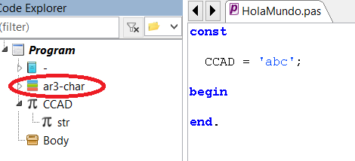

In this case, the CCAD constant has generated the type "ar3-char", which is a 3-character array, and has taken that type to contain 'abc'. Do not forget that the compiler interprets all strings as character arrangements.

Constant evaluation

Processing constants might seem simple, because they can be read directly with their value and updated in their value. And this is true for constants of type:

CONST CONST1 = 2;

But constants that have expressions as a definition, require that a prior evaluation be made, to obtain their final value, as the following case:

VAL = CONST1 + 3;

The use of this type of expression requires a prior evaluation, using an expression analyzer, to obtain the final value.

Now, if an expression evaluator is needed, we would also need to define the capabilities of this expression evaluator, such as knowing up to what level of complexity it would be supported in the expressions and how the data types would be handled.

To avoid having to create a special expression parser, we decided to use the same parser that is used for code generation (based on TCompilerBase.GetExpression). But the processing of the constants, and their expressions, is done in the process of analysis, then the calculation of the constant expressions is left, for the process of synthesis (It is actually done in optimization).

Using the same expression parser used for synthesis (code generation), in the evaluation of constant expressions, has the following advantages:

- You don't need to create an entire expression parser, or an additional error processing system.
- The syntax of the expressions and the data type is similar to that of the same Pascal language of the entire program. So you don't need to handle (and maintain) separate syntax.
- Expressions can be assigned a data type consistent with Pascal types.

On the other hand, using the expression parser of the code generator has the disadvantage that expressions cannot be evaluated in the Analysis. So it must be postponed until optimization, to be able to obtain the final value of constants that have been defined as expressions.

Constant lifecycle

Like variables and functions, constants also handle a life cycle that goes through the following stages:

Evaluate. Constant
OPTIMIZATION
ANALYSIS
Semantic Analysis
Semantic Analysis

Does it apply to TEleConsDec and TEleExpress?

This process applies only to identifier constants, because literal constants are identified and calculated (read) in the same process and do not need to be resolved.

Constants are identified and resolved in the analysis process. The calculation or evaluation is done in the optimization process, which also includes the folding of constants and other additional optimizations, described in the document "Documentation – Optimization and Synthesis".

Identifying a constant implies that its identifier is taken and concluded that it is the identifier of a constant.

Solving a constant implies that you know which constant statement it refers to. This job is executed with a simple comparison of the constant identifier with all declared constants. The code that resolves, not just constants, is in TCompilerBase.GetOperand():

function TCompilerBase.GetOperand(): TEleExpress;
...
ele := TreeElems.FindFirst(token); //Identify element
findState := TreeElems.curFind;
if ele = nil then begin
//Unidentified element.
GenError(ER_UNKNOWN_IDE_, [token]);
exit;
end;
if ele.idClass = eleConsDec then begin //Is constant
xcon := TEleConsDec(he);
AddCallerToFromCurr(it);
Op1 := OpenExpression(ele. name, xcon. Typ, otConst, GetSrcPos);
...

Name resolution is explained in section 10.4.

As the resolution of elements is done in the Analysis process, it is expected that when the optimization is initiated (See section 1.2 for more information about the processes) all the identifiers will already be resolved.

Constant expressions

Constant expressions (or constant operands), are syntactic elements that represent:

- A constant literal (of any kind) within an expression.
- An identifier referencing a constant declared in the CONST section.

Constant expressions, like all expressions, are modeled with elements of type TEleExpress, but of type otConst.

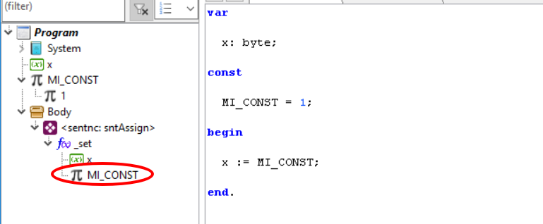

Note the difference of constant operands with the constant declaration, which although semantically can represent the same, within the AST are differentiated objects.

the characteristics of constant expressions are defined in the following table

Access: | Read-only
Element | TEleExpress
Guy: | otConst
Storage: | stConst, stRamFix

Storing a constant refers to how its value is read and saved in the compiler or executable program. For more information on storage check the document "Documentation – Optimization and Synthesis".

TYPE MANAGEMENT

From the beginning, the Pascal language has been characterized by the power offered by the handling of types, beyond the simple structures offered by the C language in its beginnings.

The implementation of Pascal types of P65Pas, is not complete, but it is still in development and is expected to cover as much as possible, with the specifications, of at least Turbo Pascal, always considering the limitations of the hardware of the CPU 6502.

Within P65Pas, the types are divided into:

- Basic Types. Like The Char, Byte or Word.
- User-defined types.

The difference between basic types, and user-defined types, is similar to the difference between system functions and user functions.

BASIC TYPES | USER-DEFINED TYPES
They always exist, from the beginning of the build, in the System drive. | They are created by code, according to the compiled program.
They are always available and from anywhere in the code. | Its access follows the rules of scope of all syntactic elements.

Despite the difference, all types are represented as instances of the same TEleTypeDec class.

The TEleTypeDec class

Within P65Pas, all data types, both basic and user-defined types, have an instance of the TEleTypeDec class associated with them:

TEleTypeDec = class(TxpEleCodeCont)
private
fSize: SmallInt;
internalTypes: TEleTypeDecs; //Container for types recursively defined.
function getSize: smallint;
procedure setSize(AValue: smallint);
public //Events
OnSaveToStk : procedure of object; //Salva datos en reg. de Pila
OnLoadTowR : TProcLoadOperand; {Used when requested to upload a
operating (of this type) in the stack. }
OnGlobalDef : TProcDefineVar; {It is called every time the
declaration of a variable (of this type)
at the global level.}
public
copyOf : TEleTypeDec; //Indicates this type is copy of other
group : TTypeGroup; //Type group (numéric, string, etc)
catType : TxpCatType; //Type category
property size: smallint read getSize write setSize; //Size in bytes of type
function groupStr: string;
function catTypeStr: string;
public //Arrays and pointers
consNitm: TEleConsDec;
itmType : TEleTypeDec;
isDynam : boolean;
ptrType : TEleTypeDec;
function nItems: integer;
public
procedure SaveToStk;
public //Identification
function IsByteSize: boolean;
function IsWordSize: boolean;
function IsDWordSize: boolean;
function IsArrayOf(itTyp: TEleTypeDec; numIt: integer): boolean;
function IsPointerTo(ptTyp: TEleTypeDec): boolean;
function IsEquivalent(typ: TEleTypeDec): boolean;
public
constructor Create; override;
destructor Destroy; override;
end;

Various events are included in the class, to perform tasks of the type. That is why, when creating a type, various routines must be implemented. Let's take as an example the creation of the byte type:

single-byte numeric type
typeByte :=CreateSysType('byte',t_uinteger,1); //the 1 bytes
...
typByte.OnLoadToRT := @byte_LoadToRT;
typByte.OnDefRegister:= @byte_DefineRegisters;
typByte.OnSaveToStk := @byte_SaveToStk;

The OnLoadToWR event generates the code that is required to load the value of a byte data, in the appropriate RTs (which in this case is only W).

The OnDefRegister event ensures that the RTs associated with the type (See section Error! The source of the reference cannot be found. ), are assigned to memory. In this case it is not necessary.

The OnSaveToStk event generates the code to save the contents of the RTs associated with the type in the stack.

Basic Types

The basic types, in P65Pas, are those that always exist, and do not need to be created to use them within the compiler, such as byte or char types.

Currently, the following basic types have been created:

System types /////////////////
typBool : TEleTypeDec;
typByte : TEleTypeDec;
typChar : TEleTypeDec;
typWord : TEleTypeDec;

They represent the boolean, byte, char, and word types, respectively.

In addition to these types, you have the typNull type (created in the XpresElemP65 unit), which is a type that indicates that no value is returned. Something like the VOID of the C language, only you don't need to specify it, within the syntax of Pascal.

The basic types are represented as an instance of the TEleTypeDec object, and are created in TGenCod.CreateSystemElements, within the System unit:

procedure TGenCod.CreateSystemElements;
...
begin
...
uni := CreateUnit('-'); //System unit
TreeElems.AddElementAndOpen(uni); //Open Unit
/////////////// System types ////////////////////
typBool := CreateEleType('boolean', srcPosNull, 1, tctAtomic);
typBool.location := locInterface;
TreeElems.AddElementAndOpen(typBool); //Open to create "elements" list.
TreeElems.CloseElement; //Close Type
typByte := CreateEleType('byte', srcPosNull, 1, tctAtomic);
typByte.location := locInterface;
TreeElems.AddElementAndOpen(typByte); //Open to create "elements" list.
TreeElems.CloseElement;
typChar := CreateEleType('char', srcPosNull, 1, tctAtomic);
typChar.location := locInterface;
TreeElems.AddElementAndOpen(typChar);
TreeElems.CloseElement;
typWord := CreateEleType('word', srcPosNull, 2, tctAtomic);
typWord.location := locInterface;
TreeElems.AddElementAndOpen(typWord);
TreeElems.CloseElement;
...

Creating types is done similarly to when you define a new type by code.

Each type is associated with RT defined for that type. For example, the byte and char types are associated with the A record. For more information on the records associated with the types, see Section 4.

The basic types are organized in groups:

TTypeGroup = (
t_integer, //integers
t_uinteger, //unsigned integers
t_float, //floating point
t_string, //string
t_boolean, Boolean
t_enum //listed
);

Not all of these groups are used in the current version of P65Pas, but they have been defined, thinking about future implementations.

The following table describes each of the groups:

GROUP | DESCRIPTION | TYPES INCLUDED
t_integer | Signed integer. | <ningone>
t_uinteger | Unsigned integer. | Byte, Word, DWord, Char
t_float | Floating-point number. | <ningone>
t_string | A string of characters. | <ningone>
t_boolean | Boolean types. | Boolean
t_enum | Types listed. | <ningone>

The idea of this field was to categorize the types, and provide additional information, which would indicate the compatibility between the types. But so far, it is seen that the usefulness of the group field is scarce and should be analyzed if it is necessary to maintain it.

Type categories

The first categorization of types is done through the catType field, of the type listed TxpCatType:

//Type categories
TxpCatType = (
tctAtomic, Basic type as (byte, word, char)
tctArray, //Arrangement of some other type.
tctPointer, //Pointer of another type.
tctObject //Multi-field record.
);

The tctAtomic types are the basic types such as Byte or Char. But it is also used in types that are copies of the basic types (See section 3.5). These would come to be the atomic types, those that cannot be divided into simpler types.

The other categories of types are no longer atomic types, but are formed from other types. They can be considered as structured types.

TctPointer types are the simplest structured types. They are references to another type of variable. Its implementation is somewhat complex, but it serves as the basis for the implementation of fixes.

TctArray types are arrays of a basic type or another non-basic type. In the current version of P65Pas, only basic type arrays are allowed.

TctObject types are records that group different types into a single structure.

User-defined types

User-defined types are also handled as instances of the TEleTypeDec class. But they are created on demand, by code.

Initially the basic types belonged to a different class from that of the user-defined types, but it was unified in the same class, to simplify the handling and to give the compiler more flexibility, because being all the types, syntactic elements, you have greater control over them, from the source code.

Consider the case of a type statement:

type
MiByte = byte;

This declaration will create a new TEleTypeDec element, and add it to the syntax tree, so that it can be recognized later in the variable declaration.

It can be easily checked that this type is recognized in the compiler by looking at the code explorer.



However, the idea of creating user-defined types is to be able to create complex structured types, from the basic types. Among them:

- Pointers to basic types.
- Basic type arrangements
- Combined records basic types.

And not only should you be able to create types from basic types, but also from other user-defined types.

Flexibility in Pascal's type declaration also means having a flexible definition for the TEleTypeDec class.

Copy Types

A simple statement of types such as:

type
MiByte = byte;

Generates a new type, which is (or at least should be) similar to the byte type. The only differences would be the name of the type, and that this new type does have a statement in the source code.

Declaring a type in this way is what is called a copy type, and internally it is saved as a user-defined type, but putting the "copyOf" field pointing to the basic typByte type.

A declaration of this type actually generates a copy of the basic type object. And although you may think that it is not necessary to create a copy, but to use the same object, there are a couple of good reasons for this:

- Although functionally a copy type is similar to a basic type, the copy type has other scope rules.
- A basic type is unique and with the same name. Many copy types can be created, pointing to the same basic type, using different names.

A copy type is identified by its "copyOf" field, which is the first field to be read of a type, before trying to work with it, because otherwise you can try to access unused fields.

To avoid errors when accessing copy types, the TEleVarDec class considers in its property "TEleVarDec.typ", if it is a copy type, and goes on to reference the copy type, if so. Then it could be said that access to the type, in the TEleVarDec class, is safe, considering that accessing its "typ" field, does not represent the original type of the variable, but its copy.

For the other cases, in which TEleTypeDec is accessed, outside of TEleVarDec, its "copyOf" field should always be checked

BASIC AND STRUCTURED TYPES

This section describes the particular implementation of the basic types within P65Pas.

Unlike the other sections, which are more general to the compiler itself, this section describes how the compiler is implemented to support this CPU architecture.

Boolean

Range of values | false, true
Type size | 8 bits
Primary storage in RT (Boolean Expression Storage) | Record A
Alternate storage | Flag Z, C
Binary representation | Variable :  $00 -> Interpreted as FALSE  $FF -> Interpreted as TRUE  Another value -> Indeterminate.  Record A:  $00 -> Interpreted as FALSE  $FF -> Interpreted as TRUE  Another value -> Indeterminate.
Important flags, associated with the operand. | <None>
Important flags, associated with the compiler. | lastASMcode -> Gives information about the ASM code generated by the last BOR or UOR.  lastASMaddr -> Complements "lastASMcode", and indicates the in-memory position where the last code snippet that indicates "lastASMcode" begins.  AcumStatInZ -> Indicates that the value stored in record A is consistent with what the Z flag indicates. This is the common.
Implemented operations | :=,=, <>, NOT, AND, OR, XOR

Boolean values are handled in a byte, rather than a bit, because the 6502 lacks bit access instructions, so it would be very laborious to work with individual bits.

The binary values ($00 and $FF) chosen to represent the Boolean type are applicable for all operand storages. The value $FF is chosen and not the one, for convenience to perform logical operations on all bits.

The variable "lastASMcode" is used profusely for the Boolean type, and helps in optimizations. It is of type TLastASMcode, defined as follows:

TLastASMcode = (
lacNone, //No special code generated.
lacLastIsTXA, {Last instruction is TXA, and it's used only
to move result from X to acumulator. }
//Flags applied to boolean expression results.
lacCopyZtoA, {Last ASM code is for obtaining boolean expression in regA
from Z.}
lacInvZtoA, {Last ASM code is for obtaining boolean expression in regA
from Z (inverted).}
lacCopyCtoA, {Las ASM code if for obtaining, boolean expression in regA,
using the bit C and copied to A. }
lacInvCtoA, {Last ASM code is for obtaining boolean expression in regA
from C (inverted).}
lacInvAtoA {Value of regA is inverted in all bits to regA}
);

These optimizations, when applied to Boolean types, only work with otFunct operands (stRegister, stRegistA, stRegistX , or stRegistY) operands. Thus, every time you have a Boolean expression, you must check the status of "lastASMcode", in order to optimize the code.

The "lastASMcode" values that are of interest for optimization are lacCopyZtoA, lacInvZtoA, lacCopyCtoA, lacInvCtoA, and lacInvAtoA. The idea is that when you want to process a Boolean operand of type otFunct, you first check the last generated code to see if you can do without it and thus reduce the amount of code generated. Typically, the last generated code, such as a "lacCopyZtoA" for example, is only code to move the value from the Z flag to the A record, so that this part of the code can be removed and code with BEQ or BNE instructions is generated directly. This form of optimization can be seen in the routines used to evaluate the conditions of the IF instructions.

The following table summarizes the above:

FLAG | APPLICABLE TO | PROCESSING
lastASMcode | Boolean expressions or other types of expressions. | Optional to process.
lastASMaddr | Boolean expressions or other types of expressions. | It is complemented by lastASMcode.
AcumStatInZ | Boolean expressions only | Optional to process.

AcumStatInz Flag

The AcumStatInZ flag provides additional information about the code compiled in a ROB or ROU.

If its value is TRUE (its default value), it indicates which accumulator value is reflected in the Z flag of the SR record, this is for example, if A=0 then Z=1. This is the most common case, because it is assumed that if a value has been set to A, with instructions such as LDA, TXA or PLA, the value of the flags of the status record is automatically changed.

If the value of AcumStatInZ is FALSE, the value of the Z flag does not necessarily reflect the value stored in record A. This can happen in very few situations, such as when some other instruction (affecting status flags) is executed, after the instruction that changes A. The following code illustrates the case:

; ROB sample code
...
LDA #1;D after this statement, AcumStatInZ reflects the value of A
LDX #0 ;D after this instruction, not anymore.
; End of ROB

Structured Types

As stated above, structured rates are types that do not fall into the tctAtomic category. These are:

- Pointers (tctPointer).
- Arrangements (tctArray).
- Objects (tctObject).

EXPRESSIONS

The handling of expressions in this compiler is very different from the classic way they are handled in Pascal. This section explains this particular handling of expressions that more closely resembles modern languages (such as Ruby) that follow the OOP paradigm.

Pascal Expressions

Expressions in Pascal are handled as mathematical expressions in Infix notation, as in the following examples:

1 + 2
a * b + c
2 - (a way b)

In this notation, the operators of the operands are clearly differentiated.

Operator
Operand

A + B

In the implementation of a classic Pascal compiler, code generation focuses on the operators, considering the data types of the operands, that is, the operators are the ones who determine how the code is generated.

Expressions in P65Pas

The expressions that P65Pas handles although they seem similar to the standard Pascal (and can be used in that same way), internally they are handled more in the style of methods and objects, of the OOP paradigm where the methods are called in the form:

<object>.< method>

Thus, each operator (such as +, -, or *) is actually a short way of calling the corresponding method.

The methods associated with operators are diverse. Some of them are:

Operator + | method _add()
Operator - | method _sub()
Operator * | Method _mul()
Operator / | method _div()
MOD Operator | method _mod()

The method names of common operations start with "_", although this is only a standard used for predefined operators, any name can actually be used when implementing a new operator (Not supported yet, in the current version).

The following table shows the equivalence between common Pascal expressions and the notation on objects used by this compiler:

Common Pascal expression | Equivalent expression in OOP
variable | variable
a + b | a._add(b)
a + b + c | a._add(b)._add(c)
a + b * c | a._add(b._mul(c))
a * b + c * d | a._mul(b)._add(c._mul(d))
a[index] | a._item(index)
a^ | a._ptrto()

REMARKS:

- Operators are shorthand ways of calling their respective methods.
- Methods, associated with operators, are functions that always return values. They cannot be used as a target for assignments. They can be considered "getters".
- The parameters of the read-only methods (CONST parameters) are never modified.
- The rules of precedence of the operators are respected when generating their equivalent versions in OOP.
As operators are nothing more than methods associated with types of objects (such as byte or char). It is possible to define these operators to new types of objects, but one can not speak of operator overload in this language, but rather that all operators need to be defined in order to be used.

The creation of new operators is not fully implemented in the current version of the compiler, but its syntax will be very similar to the creation of new methods within classes.

The fact of defining the operators in this way, has the following objectives:

- Modernize the compiler by giving object orientation from the fundamentals.
- Simplify the implementation of the code generator, so that syntax is simplified.
- Allow you to define custom operators on any type of data. This feature is not yet implemented.
- Allow a more secure implementation of the code generator, as it forces you to implement all the necessary methods. And in case you do not have implemented some method/ operator, the compiler will simply give the corresponding message.

The equivalent version in OOP, is how the expressions are understood internally, on the part of the compiler. But it is not only an internal representation, but it is also a completely valid way of writing expressions. Therefore there will be no difference between writing: "a+b" and "a._add(b)". Both will give the same result. The first form can be considered a syntactic sugar to maintain compatibility and facilitate the reading of the expression.

Note that the expression "a + b" is equivalent to "a._add(b)" and that the method _add() has the ability to return a result.

At this level there is no discussion of how operands will be stored in memory, as that corresponds to the work of the code generator.

The assignment operator ":=" (and its associated as +=, -=) is considered as one more method, with low precedence. However, unlike the other operators, this one does not return values (unlike the C language).

As we have seen, expressions are defined as simple method calls. The only condition for a syntactic element to be considered as an expression would be that it returns a value.

So for example the following examples are expressions:

123 //Numeric literal
'a' //Literal character
Object1 //Variable object
function1() //Function call
a.atrib() //Access to an attribute of an object.
a._add() //Method call that returns value

But the following code does not:

procedure1() //Procedure call
a.method() //Method call that does not return value
if a=0 then a=1 end; //Estructura condicional

Operators and precedence

The way in which an infixed expression is translated into an OOP form also considers the precedence of operators. That is why the expression:

a + b * c

It translates as: "a._add(b._mul(c))" since the operator "*" has greater precedence than the operator "+". Otherwise, it would be translated as "a._add(b)._mul(c)"

Precedence defines how calls to methods associated with operators will be generated.

We know that within the language of our compiler we can (or can) create methods associated with operators. What we cannot create are new operators and there is only a fixed number of them. These are:

OPERATORS | PRECEDENCE
~, NOT, "+" sign, "-",@, ** | 6
*, /, DIV, MOD, AND, SHL, SHR | 5
|, !, +, -, OR, XOR | 4
=, <>, <, <=, >, >=, IN | 3
:=, +=, -=, *=, /= | 2

Note that some of these operators (the "~", the "|" and the "!") do not belong to the standard Pascal (and are not used by this compiler), but are available in case you want to implement them for some type of data.

Some operators are only unary (NOT), and others can function as unaryes or binaries ("+" and "-").

One way to define a custom operator (not yet implemented) would be:

type TPunto = object
x, y: byte;
procedure sumar(dest: TPunto) operator +;
end;

Although you can associate operators with methods, what you can't do is change the precedence. Operators always maintain their precedence. This means that the symbol "*" will always take precedence over "+", no matter what method it is associated with.

Initially, in the design of the compiler, it was defined that the precedence of an operator was variable and that it could also be defined, but that generated the following problems:

- If you have overloaded methods, there is a danger of associating it with the same operator with different precedence, as in:

type TPunto = object
x, y: byte;
procedure sumar(dest: TPunto) operator + precedence 2;
procedure sumar(dest: TPunto2) operator + precedence 3;
end;

Then an additional protection rule would have to be added (which seems very restrictive), otherwise the analysis of expressions would be complicated.

- Ambiguity could be generated when a unary operator such as NOT acts on an expression such as:

not dato1 + dato2

Since it would first be necessary to apply NOT to "data1" to know the precedence of that NOT and then be able to compare it with the precedence of "+" (which depends on the types of "not dato1" and "dato2"), but it may happen that the precedence of "+" is greater than that of the NOT and then the evaluation would have to be extended to NOT (data1 + data2). To complicate even more, it could happen that the precedence of that NOT is less than that of the "+" in this new case.

- An additional complication is generated if operators are allowed to handle different precedences with different data types, because it does not allow a general verification of expressions but would force to review the precedences of those custom operators.

Objects and Methods
Just as classical expressions are composed of operands and operators, expressions in P65Pas are composed of objects and methods.

We have seen that expressions in P65Pas are made up of objects and methods.

Objects | They do not receive parameters.  - They can be associated with an object that has a Tc data type.  - They return a to data type (basic or structured type).
Methods | They must devour a value of a specific type.  - They are associated with an object that has a Data Type Tc.  - They receive a Ti(parameter) data type.  - Return a To(result) data type.

The types used in this description are:

Ti -> Represents the type that receives the item.
To -> Represents the type that returns the item.
Tc -> Represents the type to which the element is associated.

Note that Ti can be zero or several types, depending on the number of parameters it receives and the operator that emulates:

- Non-existent Ti -> In unary operators, such as: "x++" or x._plusplus()
- Ti with unique type -> In binary operators, such as: "x + y" or x._add(y)
- Ti with two types -> Ternary operators, such as "true?1:0" or _iff(true,1,0)
- You with multiple types -> No application in operators.

To complete our definition of objects and methods, we summarize in the following table:

 | OBJECT |  | METHOD
 | Simple Type or Object | Attribute | Unario Operator | Binary Operator
Example | var_byte | Objeto.att_byte | a++ | a + b
OOP notation | var_byte | Objeto.att_byte | a._plusplus | a._add(b)
Type Tc | <Doesn't it exist> | The type of "Object" | The type of "a" | The type of "a"
Type Ti | <Doesn't it exist> | <Doesn't it exist> | <Doesn't it exist> | The type of "b"
Tipo To | The same as the variable. | The type of the attribute | The type returned by _plusplus() | The type returned by _add()
Type notation | To | Tc.To | Tc.metodo():To | Tc.metodo(Ti):To
Tree diagram | To | To  Tc | Tc  To | Ti  To  Tc

It can be identified that the cases "OBJECT-attribute" and "METHOD-Unary Operator", are similar from the point of view of types. However, we will find decisive differences when analyzed from the point of view of the Code generator.

Tree diagrams will serve us for filling the syntax tree, as indicated in section 8.2.1.

Special operators

There are some special operators that might not be so at first glance, but are also treated as methods of an object.

These are:

OPERATOR | EXAMPLE | POO VERSION
Array Index | a[index]  a[index] := value; | a._getitem (index)  a._setitem (index, value)
Pointer | a^  a^ := value; | a._getptr()  a_setptr(value)

The index of an array is considered an operator, to standardize and simplify the way the compiler works. In this case, the parameter in square brackets behaves like the second operand.

The methods associated with these operators behave as described in section 7.2, however, what makes this operator special is that:

- Use two separate characters '[' and ']'.
- They usually return references to variables, i.e. they can be read/written. Operators such as + or -, return the result of expressions, which can only be read.
- It is used for both reading and writing in the same way. That is, it is read with a[i] and written in a[i].

The C difference is the most problematic, that's why when you convert the operator to method, two versions are created (getter and setter) depending on whether it is used for reading or writing:

_getItem(index)
_setItem(index, value)

Thus, although the expression a[i], can appear in the same way both when reading and when writing; the compiler will generate the appropriate call to the method according to its use.

For information on using getter or setter in expressions, see section 7.8.

The case of the Pointer operator is very similar to that of the arrays, with the difference that it would be treated as a unary operator.

Consider the definition of the following variable:

var ptr: ^byte;

When the expression is used:

ptr^

You will have to:

- Tc es ^byte
- Ti is not used, and
- To es byte.

The replacement is also done by considering a "getter" and a "setter":

_getPtr()
_setPtr(value)

Again, the use of one or the other method will depend on the use of the expression within a statement.

Functions in expressions

In the definition of expressions, the case of object methods was considered, of the form:

object.method(<parameters>)

But the case of simple function calls such as the case was not discussed:

mi_funcion(1)

This case is particular because it is not a method associated with an object or class, but is an independent function.

As the function is not associated with any classes; its corresponding in diagram would be:

.mi_func
1

The same applies to functions defined in units (other than object methods). Thus the function "func2(1, 2)" defined in the unit "Utils" would be defined as :

func2(1, 2)

And his expression diagram would be.

func2
1
2

Tree diagrams

As seen in the previous sections, it is possible to construct a diagram of the expression tree, for all expressions.

Below we show the tree of expressions of various Pascal expressions:

EXPRESSIONS | EXPRESSION TREE
1 | 1
1+2 | 1  2  _add
1 + 2 + 3 | 1  2  3  _add  _add
1 + 2 * 3 | 2  3  1  _add  _mul
(a+b)-(c-d) | c  d  _sub  _sub  a  b  _add
x > 0 | 0  _gr  x
p.x | .x  p
min(a, b) | .min  a  b
p[0].x | .x  p  0  _item

Note that all expressions, however complex they may be, always start from a single root node, which can be a:

- Simple object or variable/constant.
- Method or simple function/procedure.

Another detail to highlight is the fact that the only difference between function /procedure and method is that the latter receives as the first parameter the object that serves as the basis for the method.

The tree representations shown in the table above are not just graphical representations, but are actually created that way in the syntax tree.

Operands and expressions

Syntactically, operands are defined as those expressions that are only joined by the operators ".", "[]" or "^". Its notation in BNF would be:

operand ::= identifier { "." identifier |
"[" expression { "," expression } "]" |
"^" }



This definition, in standard Pascal, would correspond to what is called "variable". However, in our version of Pascal, which follows the OOP notation, it could represent a constant or a function (method); that is why we simply call this syntax element "Operand".

The expressions would be defined as:

expression = [pre_operator] operand [post_operator]
{ binary_operator [pre_operator] operand [post_operator]}



Expressions can be understood as a broader concept than operands, so it encompasses them. This implies that all operands are expressions at once, but the opposite is not necessarily true.

When studying the processing of expressions, we will see that some operands are also handled as expressions (since the symbols [], ^ are interpreted as if they were operators associated with a method). In this case, these operators are assigned a high precedence and the concept of operand becomes that of an expression created with operators with precedence greater than a defined one.

Assignments

As stated above, assignments are special operations within the language, but at the semantic level, they are considered as the call to a simple method.

In BNF grammar, mappings, within the compiler, are defined as:

assignment = operand ":=" expression

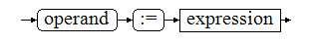

The term "operand", defined in section 7.7, must return an expression that is writable, i.e. a variable. Any other type of item will be invalid and will generate a compile-time error.

The conditions that must be met for an assignment to be valid are:

- The operand on the left side must be of type Variable (not to be confused with the data type). This implies that you have a way to write information to it or you have a setter() method.
- Both the operand and the expression must be of the same data type.

The operand, to which the variable is assigned, can be quite complex. Something like:

- variable
- object.attribute
- object.attribute^
- object.attribute^[i]

Simple cases such as access to common variables, do not require the use of "setters". The write operation is done by the compiler, as simply as copying bytes.

When the operand is special, as a pointer or array, the "setters" are used.

Consider that the "setters" are only used in the final part of the operand to be assigned. So if the operand is:

object.attribute[i].attribute[j] :=

The calls to the operand-methods are:

object.attribute._getitem(i).attribute._setitem(j)

In the expression on the right side of the assignment, "getters" are always used.

FUNCTIONS AND PROCEDURES

We know well that Pascal differentiates between Procedures and Functions, but, for simplification, when we say "functions", we will be referring to both functions and procedures.

Considering that P65Pas also has object support, the term "function" could also represent a method.

Procedures and functions

Internally, within P65Pas, all procedures are considered functions. The only difference is whether they return any information.

The syntax of the procedures in P65Pas is similar to that handled in Modula-2:

procedure SoloProc;
begin
...
exit;
...
end;

procedure Funcion: byte;
begin
...
exit(valor);
...
end;

When you want a procedure to work as a function, you only specify the type to return, and you must include the "exit" statement, with the value to be returned, passed as a parameter.

When working the procedure, only as a procedure, the assigned type is typNull, which is a type used to indicate that there is no type. It would be the equivalent of void, from the C language.

When the procedure is used, as a function, it is assigned the type indicated in the declaration. This is done in TCompiler.CompileProcHeader(), for user-defined functions.

Function representation

Within the compiler, functions are represented as instances of three possible classes:

- TEleFunBase
- TEleFunDec
- TEleFun

All of these classes are specialized elements (derived from the TxpElement class) to represent both the declaration of functions and the implementation (where both exist).

The relationship between the above classes is shown in the following class diagram:
TxpElement
TEleProgFrame
TEleFunc
TEleFunDec
TEleFunBase
The TEleFunDec class represents function declarations. It contemplates two cases:

- Declarations in the INTERFACE section of the units.
- FORWARD Statements.

The TEleFun class represents the implementation of functions. It contemplates the cases:

- Implementation in the IMPLEMENTATION section of the units.
- Implementation of FORWARD functions.
- Implementation of functions that do not have a prior declaration.

The TEleFunDec and TEleFun classes derive from the common ancestor TEleFunBase which serves for polymorphic references of functions. They are defined as different classes for:

- To be able to differentiate the declarations from the implementations and thus maintain the position they occupy (declarations and implementations) in the syntax tree, since the correct location of these elements is necessary to solve the identifiers in an appropriate way.
- Be able to check whether a function statement includes its implementation, or otherwise generate an error.

However, both classes share much of their fields and only specialize in TEleFun, with some fields dedicated to their modeling. The TEleFunDec class, evidences its main identification utility, because it only has a dedicated field:

TEleFunDec = class(TEleFunBase)
public
implem : TEleFun; //Reference to implementation element.
public //Initialization
constructor Create; override;
end;

It follows then that the strong work of the functions is done with the TEleFun class.

References that must point to both declarations and implementations are handled as references to TEleFunBase.

The problem of declaration/implementation calls

Having separate the declaration and implementation of the functions, generates an additional difficulty, referring to the control of calls or references (See Section 10.6).

The difficulty arises because some references to functions are resolved with the declaration and others with the implementation (For information on name resolution, see section 10.4), and keeping track of the calls would involve the accumulation of several calls, to the same function, in two different elements.

If you decide to accumulate all the calls in the declaration, the following problems arise:

- Not all features have declaration
- It would be going against the philosophy of accumulating all the information in the implementation and leaving the statement only as a reference.

On the other hand, if you decide to accumulate all the calls in the deployment, you would have the following problem:

- Not all declarations are going to have implementation, when they are referred, because the implementation could come later.

To address this problem, simply add calls to the declaration, when only it exists, and to the implementation, when it exists. When you find the implementation of a declaration, the calls to the deployment are moved and from that point on all the calls in the deployment will be accumulated.

This logic is seen in the TCompilerBase.AddCallerToFrom() function:

function TCompilerBase.AddCallerToFrom(toElem: TxpElement; callerElem: TxpElement): TxpEleCaller;
...
begin
//Creates caller class.
fc:= TxpEleCaller.Create;
fc.caller := callerElem;
fc.curPos := GetSrcPos; //Can be changed later if not apply.
if toElem.idClass = eleFunc then begin
//For implementation of functions, the caller are added directly.
fun := TEleFun(toElem);
fun.lstCallers.Add(fc);
end else if toElem.idClass = eleFuncDec then begin
fundec := TEleFunDec(toElem);
if fundec.implem = nil then begin
//Not yet implemented
fundec.lstCallers.Add(fc);
end else begin
//Pass call to the function implementation.
fundec.implem.lstCallers.Add(fc);
end;
end else begin
//Other elements
toElem.lstCallers.Add(fc);
end;
exit(fc);
end;

Functions as object methods.

P65Pas has simple support for declaring objects that can also include member functions or methods, as in the following example:

type TPunto = object
x, y: byte;
procedure draw(color: byte);
end;

Methods are represented, within the compiler, as simple function declarations with an additional parameter, similar to how it is handled in Python.

Thus, in the previous case, the draw() method would be saved internally as a function with the following declaration:

procedure draw(p: TPunto; color: byte);

But the call to this function can be done only in the common way:

punto.draw(0);

And not in the form:

draw(point, 0);

Object methods can be declared internally (as is done in TGenCod.CreateSystemElements), as well as by code when declaring a variable or object type.

Another characteristic of the methods is that they can be associated with an operator, as is indeed done in TGenCod.CreateSystemElements(). The use of operators as methods is a feature of expression handling in P65Pas (See section 7).

User and System Roles

Considering the way in which functions and procedures are declared, they can be classified into two types:

SYSTEM FUNCTIONS | USER ROLES
They are declared internally on the System drive. | They need to be declared by the user.
They are always accessible from anywhere in the code. | They are accessible, according to the rules of scope.

Although system functions are declared internally, in practice both system and user functions will appear similarly in the AST after the analysis process.

System Functions

System functions are declared on the "System" drive, so they do not need to be declared. Some of these functions are inc(), word(), chr(), etc.

The functions of the system are accessed through an identifier or an operator, in the source code, as if they were any function.

They are created within TGenCod.CreateSystemElements() as methods for predefined types (such as Byte._add() or Byte.sub() ) or as loose functions (such as Inc() or Dec() ).

As an example, let's look at the creation of the Inc() system function, which increments the value of a variable.

//Create system function "inc"
setlength(pars, 0); //Reset parameters
AddParam(pars, 'n', srcPosNull, typNull, decNone); // NULL, allows any type.
f := CreateSystemFunction('inc', typNull, srcPosNull, pars, @fun_Inc);
AddCallerToFromBody(H, f.BodyNode);

The definition of parameters will serve to make the validation at the time of performing the semantic analysis and fill the syntax tree. Here only one parameter is created, named "n".

AddParam() defines the parameter to use, including its name and type. The type used in this example, typNull, indicates that this function can receive any type of data in the parameter. This means that the semantic parser will allow any valid expression as a parameter (it would normally do pre-validation). It will be up to the routine fun_Inc() to determine the errors that can be generated from this debauchery.

The routine fun_I nc() is used for code generation when this phase is reached, according to the predefined rules. For more information on code generation in system functions, review the document "Documentation – Optimization and Synthesis".

User Functions

The programmer can create his own procedures or functions, using the typical Pascal syntax:

procedure MiProc;
begin
Do something
end;

The routine responsible for processing these declarations is TCompMain. AnalyzeProcDeclar(), which is a fairly elaborate routine and is supported in other specialized routines.

The mission of AnalyzeProcDeclar(), is to recognize the entire procedure declaration syntax, detect errors, and populate the syntax tree, with information about the procedure.

All functions are analyzed syntactically and semantically, and are included in the syntax tree, but the compilation to binary code will depend on whether this function is used or not, within the program.

For more information on the generation of code in user functions, review the document "Documentation – Optimization and Synthesis".

Implementing functions for operators

As stated in the Expressions Section in P65Pas, common operators such as + or – are just a syntactic sugar for calls to methods defined in various types of data, such as byte or word.

These methods are defined in TGenCod.CreateSystemElements():

procedure TGenCod.CreateSystemElements;
...
/////////////// Byte type ////////////////////
//Methods-Operators
TreeElems.OpenElement(typByte);
CreateBOMethod(typByte, ':=', 2, '_set', typByte, typNull, @ROB_byte_asig_byte);
CreateBOMethod(typByte, '+=', 2, '_aadd',typByte, typNull, @ROB_byte_aadd_byte);
CreateBOMethod(typByte, '-=', 2, '_asub',typByte, typNull, @ROB_byte_asub_byte);
CreateBOMethod(typByte, '+' , 4, '_add', typByte, typByte, @ROB_byte_add_byte);
CreateBOMethod(typByte, '+' , 4, '_add', typWord, typWord, @ROB_byte_add_word);
CreateBOMethod(typByte, '-' , 4, '_sub', typByte, typByte, @ROB_byte_sub_byte);
...

The creation of these methods is entrusted to the CreateBOMethod() routine that allows you to create a new function, associated with a type and associate it with an operator, with a certain precedence. Internally it calls AddFunctionUNI() as when creating a user-defined function. The code was designed in this way to be able to implement, in the future, the creation of custom operators.

All of these operator-methods are created within the System unit, so they could be viewed with the IDE's Code Explorer:

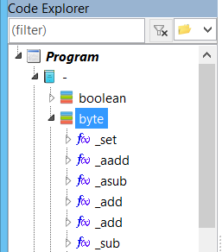

Until the current version of the compiler, all the operator-methods of the System unit are defined as INLINE functions, but that could change in the future.

INLINE functions are used for cases where the code required to implement the operation is reduced. For example, the code for the implementation of byte additions and subtractions is so small that using a subroutine for this would involve spending more memory on ter the calling code, and the JSR and RTS instructions. Not to mention that you would lose clock cycles and a level in the call stack.

In general, it is expected that the subroutines implemented:

- Be as small and efficient as possible. If you can handle two versions optimized in space and speed, it would be better, although at the moment only one version is used.
- Use as few records as possible. Preferably they should not use auxiliary variables, but only the available work records. But if there is a need for more records, it should be preferred to use work records, rather than auxiliary variables.
- That they can integrate as many operations into a single code. For example, if you implement a routine that does division and residue in a single code, it will help in optimization.
- Return values in compliance with the return values standard. For example, if routines are going to return a Word value, they should return their result, directly, in the H and W records (avoiding having to add value copy instructions).
- The input parameters are also work records: A mandatory, and H, or E or U, in that order of priority.

SYNTAX TREE

Fundamentals

P65Pas, like most compilers, use an internal data structure, called a syntax tree, to support compiling and generating code.

This syntax tree should be considered an AST or abstract syntax tree, because it does not strictly represent the source code, but a more digested version that facilitates the task of generating code.

As in the classic compiler design, the syntax tree sits between the compiler and the code generator:

This container, effectively, has the structure of a tree and allows to represent the various syntactic elements (variables, constants, procedures, types , statements, ...) of the syntax of the programming language used.

The functions of the syntax tree are:

- Serve as the main container for the syntactic elements of the program.
- Verify the duplication of names, in the declaration blocks.
- Resolve names, in code blocks. Model namespaces.
- Serve as a source for the code generation process. This better separates the parts of the compiler and makes code optimization easier.

As the compiler explores the source code, it creates the syntax tree or element tree. The element tree is an object of the TXpTreeElements class, which is defined in the unit "XpresAST". It consists of a root node, which represents the main program.

The element tree is not only a structure to store the various elements of the program, but serves at the same time, as a representation of the namespaces or scopes of all the source code, so that it serves to solve names (See section 10.5).

A graphical representation of the syntax tree, we have it in the IDE of P65Pas, in the panel named as "Code Explorer":

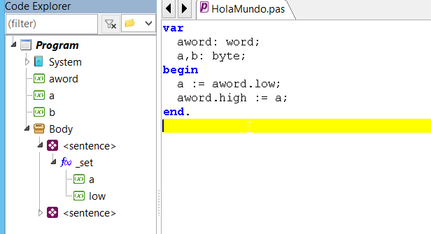

Functions, and system variables, are also created within the syntax tree, as well as statements or expressions.

The syntax tree stores all the elements of the syntax that are necessary for code generation. Comments or blanks have no representation within the syntax tree.

The elements that constitute the nodes of the tree are objects of the "TxpElement" class (See section 3) and can therefore represent all the syntactic elements of the language.

To see the type of any element in the tree, simply access the tree properties window, making use of the context menu:

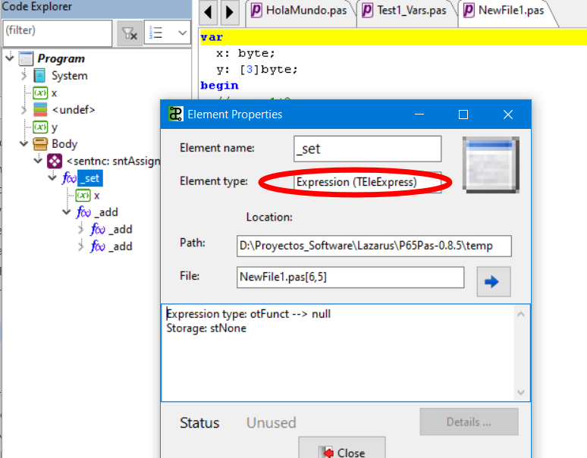

In the figure above, the selected element "_set" is of type TEleExpress which is normal for elements that are within an assignment statement.

The properties window also displays additional information, according to the type of item selected.

Structure

The syntax tree is built from scratch in the code, without using any additional libraries to the standard libraries.

The syntax tree contains nodes of type TxpElement, but the tree as a structure is defined with the TXpTreeElements class, which is the main container, and which contains the node "main", from where the other nodes begin to branch, taking advantage of the fact that the TxpElement objects include an "elements" list field, which can contain in turn, other TxpElement objects.

TXpTreeElements

main: TeleProg

TEleConsDec

TEleVarDec
Elements

...

The following figure shows the AST representation of a simple code:

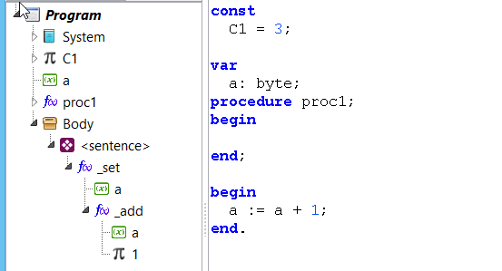

There are certain nodes that contain other nodes. When a node contains no more nodes, we say that it is a terminal node.

Each element of the syntax tree is also called a "Node", as an analogy to the graphical form of a tree.

The syntax tree follows some general rules. In principle, an AST can be generated for a program or for a unit.

- An AST can contain, at the main level, zero or many elements of type: units, constants, variables, types, or procedures.
- An AST must contain, at the main level, only one element of type "Body" that must always be at the end.
- Unit items should always appear at the top of the list, at the main level.
- Constant elements, variables, types and procedures, can appear multiple times and in no particular order, as long as they respect rules 2 and 3.

The procedures follow similar rules:

- A procedure can contain, at the main level, zero or many elements of type: constants, variables, or types.
- A procedure must contain, at the main level, only an element of type "Body" that must always be at the end.
- Constant elements, variables, types and procedures, can appear multiple times and in no particular order, as long as they respect rule 2.

These rules are determined, mainly, by the definition of the Pascal language and could vary in implementations for other languages.

The definition of the syntax tree is recursive, with respect to procedures, because they might contain other procedures as well, but in the current version of the compiler, nesting procedures is not allowed .

The syntax tree is an ordered structure, it has a first and last element.

Duplication of names

The identifiers of the elements must be unique in their scope, so that the compiler can accurately identify them when they are referenced, within the code.

By "scope," we mean a level of the syntax tree. For example, a local variable cannot have the same name as another local variable, on the same node as the first.

However, it is completely valid to have a local variable with the same name as a global variable.

Duplication of names should be avoided, regardless of whether they are elements of different types. There cannot be a unit with the same name as a constant.

To prevent duplication of names, the TxpElement.DuplicateIn() method is implemented, which performs a linear search on a list of items.

The duplication of names is always done in the declaration sections:

program aaa; //No need to see duplication, it is the first identifier.
uses
unit1, unit2; //Verification of duplicity.
const
a = 1; //Verification of duplicity.
where
x, y: word; //Verification of duplicity.

procedure proc(par1: bit); //Verification of duplicity, except the first one.
where
p1, p2: bit; //Verification of duplicity.
begin
p1 := 1;
p2 := par1;
end;

where
x1, x2: byte; //Verification of duplicity.

begin
Program Body
end.

Within the code section (Body), there is no verification of duplicity, but resolution of names.

Duplication for constants or variables is simple, but for functions, it is different because there can be several functions with the same name, in the case of function overload.

Name resolution

Name resolution is understood as the process that allows to identify precisely to which element an identifier refers in the source code.

So, for example, if the statement appears in a source code:

x := 1;

The compiler must know if "x" refers to a variable, constant, type or function (and thus verify the syntax). The simple name "x" may be referring to a local, global variable or a variable defined in one of the units used.

Within Pascal's philosophy, all names are resolved at compile time. That is, the compiler must accurately resolve all identifiers in order to generate the executable.

The naming resolution includes two parts:

- Exploration.
- The comparison.

The scan is done as indicated in section 10.5.3.

FindFirst() y FindNext()

Within the code, there are several methods to solve names, but the main ones are two:

function TXpTreeElements.FindFirst(const name: string): TxpElement;

function TXpTreeElements. FindNext: TxpElement;

These methods are used separately, to optimize the process of searching for identifiers, when handling overloaded functions (or procedures), since it is common that before identifying the correct function, other versions of the same function are found.

Having the search functions, separately, allows you to continue a search at the same point where it was left, so the exploration will not be done in the whole tree, but only until you find the correct version of the function, except, of course, when the function is not found.

To save or restore the state of a search, you must use the "TxpTreeElements.curFind" field of type TxpFindState. An example of using "curFind" to save the state of a search can be found in TCompilerBase.GetOperand().

The "curFind" field allows you to perform nested searches, using FindFirst() and FindNext().

One of the difficulties in the implementation of FindFirst() and FindNext(), is that they must work with the AST filling up, this happens because the creation of the AST is done with all the nodes resolved.

The FindNext() search algorithm is more or less as follows:

- The current search node "curFind.Node" and the current search index "curFind.Idx" are defined.
- The search in "curFind.Node.elements" starts from the position "curFind.Idx-1", backwards.
- If the searched element is not found within "curFind.Node.elements", it skips to the parent node of "curFind.Node".
- The search is repeated in the same way on that parent node.
- If the parent node is the main program (node "Main"), it is searched in the units.

The following tree shows how a name would be resolved through the AST:



Note that this process is supported by the fact that the elements of the syntax tree are ordered.

Typically, name scanning is descending at the tree level, so you avoid considering local variables from other procedures.

But when it is required to search for the name, within units, an exception occurs, in the normal scan flow:



In this case, you must raise the level to access the elements of the unit, which functions as a container of its own. The search here is only done at the first level of nesting, and only for the elements of the INTERFACE section.

Name resolution is done whenever the compiler has to execute or evaluate some code. This happens only in the Analysis process (See section 1.2 for the compiler structure), where the AST that contains valid references to the affected syntax elements is created.

Identifier Comparison

The id scan is performed until a name that matches the searched name is found. However, functions are an exception.

The following table shows how the comparison is made:

ELEMENT | WAY TO SOLVE
Constant | Identifier matching.
Variables | Identifier matching
Types | Identifier matching.
Procedures | Matching of identifier and type of parameters.

The need to check the parameters in the procedures, complicates the process, but is necessary to withstand the overload of procedures. Without this case, only a simple search function would suffice.

You could handle a single, simpler function that scanned the entire syntax tree, to find the different versions of the function (including the units), and then compared each of them; but this would have to be done, for each function, and it would be too cpu-heavy a process.

Scan identifiers

Identifier scanning refers to the way the AST is scanned to find the items it refers to.

This exploration is usually upward, by climbing levels through the AST. That is, from the most nested elements to the most external.

The scanning of identifiers, to resolve them, is related to the Calls or References, described in section 10.7, since resolving an identifier will involve generating a call to the resolved element.

In accordance with the cases in which the calls are generated, for the exploration of identifiers , the following cases are considered:

- Calls from the program/function body (TEleBody).
- Calls from declarations (constants, variables, and types).

For more information on how these calls are generated, go to section 10.7.

Calls from TEleBody

Most calls occur from the body of the main program or functions (TEleBody).

Let's consider the following code:

where
x: byte;
and: byte;
begin
x := 1+(2+y);
end.

The AST shall take the form of:

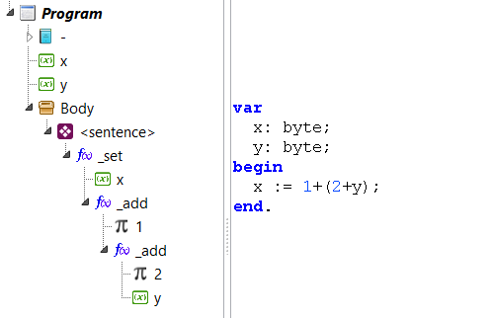

The resolution of "x" (in the analysis) is performed while the current node is the statement "<sentence>", if the current node is taken as the starting point of the scan, the scan flow would be:

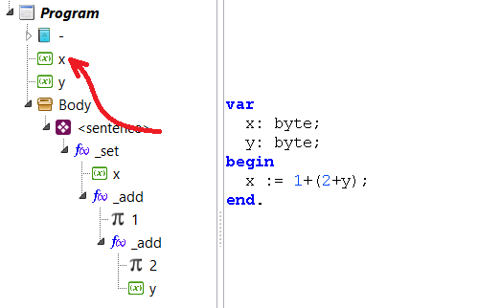

Which, not bad. But let's now consider the "and" resolution. This occurs when the current node is the innermost "_add" function. In this case the resolution, from the current node, would be as in the following figure:

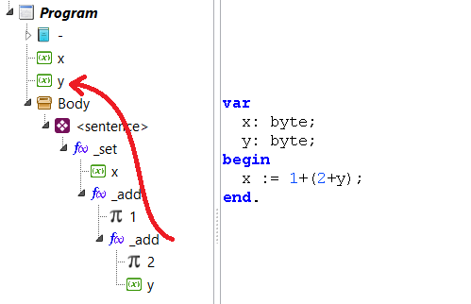

As such a search would be inefficient, since the declarations are above the "Body", a form of search has been designed that considers the current code container or "Body".

The current code container is stored in "TXpTreeElements.curCodCont" and kept up to date when a TEleBody element is opened or closed.

Calls from Declarations

Calls from statements are resolved in the same way as calls from TEleBody, from the point of the declaration, backwards.

The TXpTreeElements.FindFirst() function is prepared to consider this case as well. Because first check if you are inside an "eleBody" node or not:

function TXpTreeElements.FindFirst(const name: string): TxpElement;
begin
curFind. Name := UpCase(name);
curFind.inUnit := false;
if curCodCont=nil then exit(nil);
if curCodCont.idClass = eleBody then begin
...
Result := FindNext;
end else begin
...
Result := FindNext;
end;
end;

Filling the syntax tree

The filling process is done in the Analysis process (See section 1.2), which is executed with TCompMain.DoAnalyzeProgram() or TCompMain.DoAnalyzeUnit().

In this process of exploring the source code, all accessible elements of the main program, and all the units used by the program (including the units also used by these units) are included in the syntax tree.

The elements of the syntax tree are not added directly to the listings of the container, but there is a group of special methods for entering elements. These are:

TXpTreeElements = class
...
public //Functions for tree filling
function AddElement(elem: TxpElement; verifDuplic: boolean=true): boolean;
procedure AddElementAndOpen(elem: TxpElement);
procedure AddElementToParent(elem: TxpElement; AtBegin: boolean);
procedure OpenElement(elem: TxpElement);
procedure CloseElement;
...

Items are added sequentially with the option to use the same items as new item containers.

Considerations

One of the characteristics of filling routines is that they are oriented to work in the following way:

- Select working node with OpenElement().
- Do something with the current node.

That is, you do not usually work directly with any node, but you must make the selection first, at least for tasks such as adding new nodes.

For example, the following code shows how to add a new node to the syntax tree:

TreeElems.openElement(curSent); //Select worker node
TreeElems.AddElement(newNode); //Adds a new node to the curSent node.

Then, if we wanted to add a new node to "newNode", we would have to open it first with openElement().

Another important consideration is that for a node to accept new nodes, it must have its list of child elements initialized (Attribute: TxpElement.elements).

This is usually done when the element is first added to the tree, using AddElementAndOpen(), rather than just Using AddElement(). Or put another way: If we know that a node, which we are going to add to the syntax tree, is going to have child nodes, we must add it with AddElementAndOpen()..

This slightly strange feature, and which initially complicates the handling of nodes, has remained so since the first versions of the compiler, because it allows you to avoid creating the list of child modes (TxpElement.elements) unnecessarily, improving the performance of the code.

Calls or Referrals

In the syntax tree, not only are syntactic elements stored in the structure, but also the call relationships between these elements, such as calls or references that are made to an element (such as a variable), from another element (such as the body of a procedure) of the source code.

Calls between elements are identified using the TxpElement.lstCallers field that is inherited to all types of elements:

TxpElement = class
...
public
//List of functions that calls to this element.
lstCallers: TxpListCallers;
...
end;

This field is a list of all the "callers" elements of this element. A "caller" element of a base element is another element that calls the base element. A "caller" can only make calls from these points:

- The body of a function or the main program ( TEleBody element).
- Declaration of a constant (TEleConsDec element).
- Variable una declaration (TEleVarDec element).
- Declaration of a type (TEleTypeDec element).

The following diagram shows the points from where calls to other items are expected.

const
<from here>
where
<from here>
type
<from here>
begin
<from here>
end;

Calls from these points are all optional, as explained below.

Calls from TEleConsDec

Defining constants can include complex expressions, such as those used in a TEleBody, with the proviso that they must always return constant values:

Const
CONST1 = 1; //Declaration of a constant
CONST2 = CONST1 + 1; //Reference to another constant

The expressions included in the constant definition can be viewed from the code explorer:

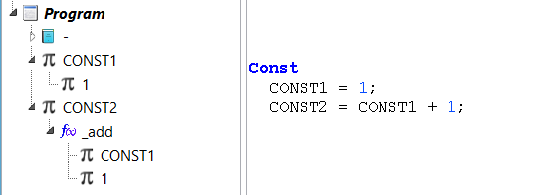

The way they appear in the syntax tree is similar to how expressions appear in common statements.

Calls from TEleVarDec

The variable declaration, in some cases, may also include references to other elements:

where
x1: absolute byte CONST1; //Reference to a constant
x2: absolute port PORTB; //Reference to another variable
x3: MyType; //Reference to a type

References can be to constants, variables, or types.

Reference to other elements, from variable declaration, is a special case, because most variable declarations will not include references.

Calls from TEleTypeDec

The declaration of types may also include references to other types:

type Tipo1 = record
x: Type_ant; //Reference to another type
end;
type Type2 = otro_tipo; //Reference to another type

The references of the TEleTypeDec elements are used to determine which types are used and which are not.

Initially, in the design, it was not considered to keep track of these references, but it is included for the following reasons:

REASON 1: It was found that statements such as "type t = ARRAY[CONST1] OF BYTE;" did not update the expression "CONST1", if the type was not used; which makes sense, because of the current way of working of the compiler, where arrangements are handled as classes. Of course, the problem can be solved (without much complication) assuming that all types are used, but this leads to REASON 2.
REASON 2: It is expected that, in the future, the declaration of types may involve the generation of additional code. If so, it is convenient by optimization, to determine the types that are used.
REASON 3: For order and uniformity, the compiler is expected to carry the reference of all types of elements used.

Calls from TEleBody

These calls are the most common. They happen when variables, constants, or functions are used from within the body of the main program or a procedure:

where x: byte;
begin
x := 1; //A call to "x" is added here
func1; //A call to "func1" is added here
x := 0; //Here is added another call to "x"
end;

Being strict, calls occur from specific points in a sentence; however, only the reference to the TEleBody body is saved, which is sufficient precision for the purposes we want, which is basically to determine the variables used from within a procedure.

Deploying Calls

Calls between syntax elements have two parts:

- The element called (called)
- The caller element

A "caller" element is modeled with a TxpEleCaller record, which is defined as:

TxpEleCaller = class
curPos: TSrcPos; //Position from where it is called this element.
caller: TxpElement; //Element that calls this element.
function CallerUnit: TxpElement; //Unit/Program from where it is called this element.
end;
TxpListCallers = specialize TFPGObjectList<TxpEleCaller>;

The "caller" field is the reference to the calling object and, in theory, could only point to TEleBody, TEleConsDec, TEleVarDec , or TEleTypeDec.

The information of the calls between elements is necessary, in order to be able to:

- Detect unused items, so that the code can be optimized.
- Implement the mechanism of reusing procedural parameters, because to know which parameters can be reused, you need to have the call tree.
- Determine the nesting level of calls between procedures.

To register a call to an item , you must use one of the following functions:

TCompilerBase = class(TCompOperands)
...
public //Callers methods
function AddCallerToFrom(toElem: TxpElement; callerElem: TxpElement): TxpEleCaller;
function AddCallerToFromCurr(toElem: TxpElement): TxpEleCaller;
...

AddCallerToFrom() is the most general function and the idea is that it is only used by AddCallerToFromCurr(), not directly; this is to limit the types of elements that can generate calls, because AddCallerToFrom() allows you to record calls from any type of element.

AddCallerToFromCurr() would be the preferred routine for logging calls. Se executes as the source code is scanned, in the filling of the AST, and all calls are included, from all functions or units, regardless of whether these functions or units are used later.

AddCallerToFromCurr() generates a call to an element, from the current point, which must be a code container (See section 10.6.6).

Knowing these dependencies helps to implement optimizations in the synthesis process.

To determine the number of lstCallers elements is called, using the nCalled method:

function TxpElement.nCalled: integer;
begin
Result := lstCallers.Count;
end;

Code containers

We said that element calls can only be produced from the TEleBody, TEleConsDec, TEleVarDec, or TEleTypeDec elements.

These elements are classified as "Code Containers", because they are elements that can contain expressions; and it is these expressions that can finally make references to other elements.

Unlike bodies (TEleBody), declarations of constants, variables, and types can only contain limited expressions, as shown in the previous sections.

The elements, which are Code Containers, are identified because they derive from the TxpEleCodeCont class, which is simply an empty class, but which serves as a common ancestor to all elements that can generate calls to other elements:

TxpEleCodeCont = class(TxpElement)
end;

TEleTypeDec = class(TxpEleCodeCont)
...
end;

TEleConsDec = class(TxpEleCodeCont)
...
end;

TEleVarDec = class(TxpEleCodeCont)
...
end;

TEleBody = class(TxpEleCodeCont)
...
end;

Code containers open and close as the various parts of the source code are explored. The routines responsible for controlling the opening of code containers are:

TXpTreeElements.AddElementBodyAndOpen()
TXpTreeElements.AddElementConsAndOpen()
TXpTreeElements.AddElementVarAndOpen()
TXpTreeElements.AddElementTypeAndOpen()

And there are four because each one is reserved for a type of code container. These routines are similar to AddElementAndOpen(), but these routines create the code container and update "curCodCont" which is the variable that controls the current code container, so that when they point to an item, it is because that code container is open; otherwise they will target NIL.

To properly control code containers, you should use these functions every time you process a body, variable or constant or type declaration, instead of using TXpTreeElements.AddElement().

The current code container is independent of the nesting level we are at when exploring the AST. For example, when the scan of a TEleBody is started, the container is opened with AddElementBodyAndOpen() that updates "curCodCont" to the open TEleBody, and then you can advance in the exploration of deeper levels of the expressions, while "curCodCont" will continue to point to the initial body.

"curCodCont" will only be cleaned when the TEleBody is closed with TXpTreeElements.CloseElement(). Making use of TXpTreeElements.CloseElement(), will have no effect on "curCodCont", when you close another element other than a code container.

procedure TXpTreeElements.CloseElement;
{Close the current node and returns to the parent node.}
where
isCodeContainer: Boolean;
begin
isCodeContainer := (curNode=curCodCont);
if curNode.Parent<>nil then begin
curNode := curNode.Parent;
end;
if isCodeContainer then begin //We are closing a Code container
curCodCont := curNode.codCont; //Restore last value
end;
end;

Only one variable ("curCodCont") is used to control code containers, but code container nesting is allowed.

"Callers" and "called".

Note that items save the list of items that call them or "callers," but do not save the list of items they call or "calleds."

This information exists and is stored in two lists, of the TxpElement class:

lstCalled : TxpListCalled; //Items called directly
lstCalledAll: TxpListCalled; //All called elements

But unlike the "lstCallers" list, these are not filled at compile time, but must be calculated on demand when this information is required, which is after code analysis.

The content of this list is obtained entirely from the "lstCallers" list which is all that is needed. The update of the lists "lstCalled*", is done in TCompilerBase. UpdateFunLstCalled():

procedure TCompilerBase.UpdateFunLstCalled;
where
fun : TEleFun;
itCall : TxpEleCaller;
whoCalls: TEleBody;
n: Integer;
begin
for fun in TreeElems.AllFuncs do begin
if fun.nCalled = 0 then continue; //No usada
Processes calls made from other functions, to fill
his list "lstCalled", and thus know who he calls
for itCall in fun.lstCallers do begin
Add the call reference to the function
if itCall.caller.idClass <> eleBody then begin
According to design, itCall.caller should be TEleBody
GenError('Design error.' );
exit;
end;
whoCalls := TEleBody(itCall.caller);
All calls are added (even if they are to the same grant) but
then AddCalled(), filters them.
whoCalls.Parent.AddCalled(fun); //Add to the procedure
end;
end;
{Update the fun.lstCalledAll list with all calls to all
functions, whether directly or indirectly.}
for fun in TreeElems.AllFuncs do begin
n := fun. UpdateCalledAll;
if n<0 then begin
GenError('Recursive call or circular recursion in %s', [fun.name], fun.srcDec);
end;
end;
if HayError then exit;
Update the main program
TreeElems.main.UpdateCalledAll; //It should not give recursion error, because the functions have already been verified
if TreeElems.main.maxNesting>128 then begin
{Stack is 256 bytes size, and it could contain 128 max. JSR calls, without
considering stack instructions.}
GenError('Not enough stack.' );
end;
end;

This function is called in TCompiler_PIC16. DoOptimize() because this update needs to be performed for some optimization tasks and before code generation.

UpdateFunLstCalled() performs two additional tasks:

- Detect cases of recursion or circular recursion.
- Detect possible cases of pile overflow, due to excess nesting.

Elements called

Although it has not been specified directly, there is only a group of items that can be called. These are:

- Functions
- Constant Statement
- Variable declaration
- Type declaration

Also the units can be referenced, but at the moment this functionality has not been implemented.

A particular case of references, for purposes in addition to simple usage determination, are references that are created from certain assembly instructions to assembler tags of the same block.

Program Frameworks

Program frames are special elements of the syntax that are also represented as nodes within the syntax tree:

Within the compiler, program frameworks are modeled as syntax elements that descend from the TEleProgFrame class.

TEleProgFrame = class(TxpElement)
public
function BodyNode: TEleBody;
public //Handling calls to exit()
lstExitCalls: TxpExitCalls;
procedure AddExitCall(srcPos: TSrcPos; blkId: TxpSynBlockId);
function ObligatoryExit: TxpExitCall;
public //Inicialización
procedure Clear; override;
constructor Create; override;
destructor Destroy; override;
end;

The main feature of a program framework is that it has a body or TEleBody element, which is the one that actually contains the statements. Additionally, a program framework may include various sections of variable declarations, constants, types, or functions/procedures.

In the current version of the compiler, the following elements are defined as program frameworks:

- TEleProg -> Main Program.
- TEleFunBase -> Function or procedure.
- TEleUnit -> Unit.

The code explorer of the IDE can help us, to better visualize, the program frameworks:

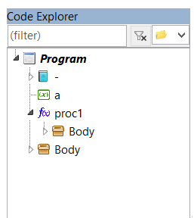
TEleProg Program Framework

TEleFunBase Program Framework

The units are also considered as program frameworks, because they include declarations and also have a body, which would be the INITIALIZATION section. The FINALIZATION section can be considered as another body, but this would be a special case.

The body of a program framework, the element of the TEleBody class, ultimately contains the program's statements.

Syntax blocks

Syntax blocks are a technique that allows you to keep track of the block in which the compiler is currently located.

Syntax blocks are regions of the source code, which are defined by the structures of the language.

Existing blocks, currently in P65Pas, are defined by the enumerated TxpSynBlockId:

TxpSynBlockId = (
sbiNULL, //No block (in the same Body)
sbiIF, //bloque IF
sbiFOR, //bloque FOR
sbiWHILE, //bloque WHILE
sbiREPEAT //bloque REPEAT
);

Syntax blocks serve to identify the interior of conditional and loop structures. If you are not inside these structures, the block is said to be sbiNULL.

Syntax blocks only make sense in the part of the code where there can be instructions, i.e. inside the TEleBody nodes.

Therefore, syntax blocks are handled in containers within the TEleBody elements :

TxpSynBlock = class
id : TxpSynBlockId;
function idStr: string;
end;
TxpSynBlocks = specialize TFPGObjectList<TxpSynBlock>;

...

TEleBody = class(TxpElement)
...
blocks : TxpSynBlocks;
procedure OpenBlock(blkId: TxpSynBlockId);
procedure CloseBlock;
...

The TxpSynBlock class represents a block of syntax and is an object that is stacked in the "blocks" list, as nested blocks are explored.

By reading the value of the elements of "blocks", at any point in the compilation, you can know in detail the level of nesting of the code.

Syntax blocks are another structure that the compiler uses to represent the source code. It is not similar to the syntax tree, but was created to fulfill another goal.

Both structures (syntax tree and syntax blocks) complement the information you have in the source code, but serve different purposes. Currently, syntax blocks are only used to implement optimizations in the compilation of procedures (See document "Documentation – Optimization and Synthesis").

AST Final Status

The AST serves as a workspace for different processes. Most of them are produced in the process of optimization and synthesis; and are described in the document "Documentation – Optimization and Synthesis", but in the Analysis process (described in this documentation) the syntax tree ends up complying with the following rules:

- The AST contains all the necessary information to perform the optimization and synthesis phases. That is, once filled in the Analysis, you don't need any other source code information to generate code.
- The order of the AST elements reflects the order in which the source code is explored.
- All AST nodes are with the names already resolved. That is, all the referenced names have already been searched and found in the source code (and exist in the AST).
- All AST nodes are already differentiated as elements. That is, you already know who TEleExpress or TEleVarDec or TEleUnit or ...
- All AST nodes, of type expression (TEleExpress), already have their data type defined. This is made possible by Pascal's characteristic as a "typed" language.
- AST nodes, of type expression (TEleExpress), might not have storage defined. Unlike the data type, storage cannot be defined in advance, due to optimization issues and must be defined in later phases.
- Some TEleConstDec nodes may not be evaluated for value. This happens when the constant is declared as an expression that needs to be evaluated (See section 4.1).
- Some TEleExpress nodes of type otConst may not be evaluated at their value. This happens when they reference an untested TEleConstDec.

SENTENCES

Every program in Pascal is mainly composed of sentences. Statements are the instructions that make up a program.

The following code, for example, has 3 statements:

begin
proc1(x, y);
b := 1;
if a=0 then a=1; end;
end;

Conditionals as well, such as repeat or while loops, are considered as a single statement that can contain internal blocks of code

Statements are grouped into blocks of code, represented by the classes:

- TEleBody -> Blocks of code within functions, units or the main program.
- TEleBlock -> Code blocks within conditional structures, loops, or BEGIN blocks... END.

Do not confuse the code blocks with the program frameworks, described in section 9.8. Code blocks are containers that include declarations and a main code block. Code blocks contain only statements.

Types of sentences

All statements are modeled within the compiler as an element of the TxpEleSentence class. However, this statement can be of various types, which are represented by the following listed:

TxpSentence = (
sntNull, //Default value
sntAssigm //Assignment
sntProcCall, //Procedure call
sntAsmBlock, //ASM block
sntBeginEnd, //BEGIN-END block
sntIF, //Conditional IF
sntREPEAT, //REPEAT Loop
sntWHILE, //WHILE Loop
sntFOR, //FOR loop
sntCASE //Conditional CASE
);

This classification is consistent with the typical definitions of the Pascal language, (Review the syntax diagrams that define the Pascal language).

It remains this way, even though the compiler has a different approach (See section 8.2), as an initial step in the implementation of the compiler, because in previous implementations (which unified the sntProcCall and sntAssign types) they generated identification and implementation problems.

That is why we are trying to keep the simple definition of the usual Pascal, hoping that it will also facilitate the implementation and keeping in mind the possible future extensions.

All TxpEleSentence objects have the type defined in their field "sntType", which is basically their only specialized field:

TxpEleSentence = class(TxpElement)
public
sntType: TxpSentence; //Sentence type
constructor Create; override;
end;

Procedure Call statements

Expression-type statements are those that are identified as being of type sntProcCal.

These types of statements include a single principal node that represents a function or method that could also be an operator in its method version (See Section 8.4 for more detail).

The following figure shows the diagram, in the syntax tree, that generates a statement that only calls a procedure:

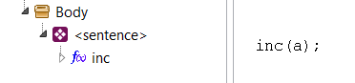
This expression falls into the sntExpres category, because it is a call to a procedure.

Assignment statements

Assignment statements are identified as sntAssign.

These types of statements are similar to those of type "Procedure Call", but they mainly represent a call to the assignment method _set().

The following figure shows the statement that generates an assignment expression:

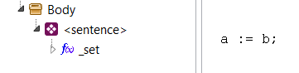

It can be seen that the assignment operator has been replaced by its corresponding method _set(), and therefore could be seen as a particular case of "Procedure Call", but assignments are special methods that deserve to be treated in a special way as well.

It can be considered that the method _set() is defined in such a way that the first parameter is always of the VAR type because it is expected to obtain a physical address to which to assign.

Expressions of type "a+b", would also be encoded as methods, but the compiler only allows expressions with operands for assignments, so these types of expressions will generate error:

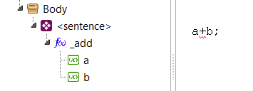

The rules that the compiler applies to verify that an expression is valid can be seen in the TCompMain.AnalyzeSentence method and in summary are:

- That is a call to a function/procedure/method (without using operator), or
- Let it be an expression of assignment, with a single operand on the left side.

Expressions that include only one operand are also rejected as valid statements because they do not generate a valid method:

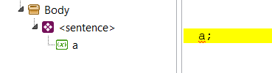

Such an expression will give a compile-time error. A variable-type node can only appear at a more nested level of the expression.

In conclusion, it can be said that:
All valid statements that represent an expression (type sntExpres), include a single child node (TEleExpress class) of type otFunct.

Expressions

Section 7 explained how expressions are handled in the compiler, but did not indicate how they are implemented internally.

Here we will detail, a little more deeply, the implementation of expressions within the compiler.

As we saw, in the previous section, expressions are handled as objects of the TEleExpress class, within Statement nodes.

Also each of the operands and methods that make up the expression, are also objects of the TEleExpress class. That is, all nodes within an expression statement are of the same TEleExpress class.

We also saw that expression statements begin with a single child node of type otFunct.

The following figure shows the statement that generates an assignment expression:

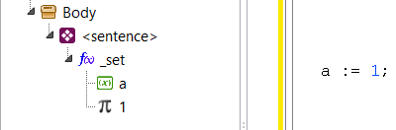

Assembler Blocks

Assembly blocks are blocks that contain assembly instructions. They are statements of type "sntAsmBlock".

As the analysis of these blocks is relatively complex, a special chapter has been created in section 12.

Conditional

Conditional expressions are a special type of statements that model IF statements, in their various forms:

IF ... THEN ... END;

IF ... THEN ... ELSE ... END;

IF ... THEN ... ELSIF ... END;

IF ... THEN ... ELSIF ... ELSE ... END;

Unlike standard Pascal, this compiler supports syntax similar to that of Modula-2.

For the filling of the AST, by uniformity, the last section ELSE, reads as if it were a section: ELSIF true THEN ... because the behavior is similar. In this way all conditionals are reduced to a more general case:

IF <condición> THEN <bloque>

ELSIF <condición> THEN <bloque>

ELSIF <condición> THEN <bloque>

...

END;

This modeling will be reflected in the syntax tree and will help simplify subsequent code generation.

The following image shows how a simple conditional is modeled in the AST.

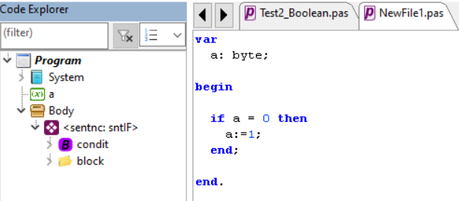
The entire conditional itself is considered to be a statement of the sntIF type.

The "condit" element is a container that represents the conditional Boolean expression that controls the IF. Internally it contains the expression of the condition (if there is only one) or the set of expressions that needs to be evaluated to obtain the result of the condition.

The "block" element is of the TEleBlock class and is similar to a TEleBody container, because it can contain one or more statements or instructions.

The following images show the case of a conditional in the AST, which includes an ELSE:

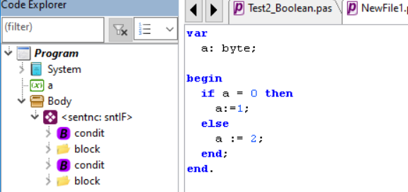

In this case, the second condition contains only one constant, with the fixed value TRUE, which is how the ELSE is modeled.

A conditional with an ELSIF will be displayed in the AST as shown in the figure:
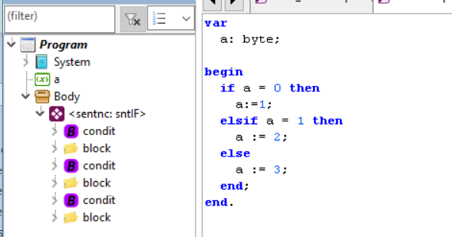

The creation of the conditionals in the AST is done in TCompMain.AnalyzeIF().

Structure of a conditional

To study the structure of a conditional in the AST, let's consider a simple conditional, such as the one shown in the following figure:

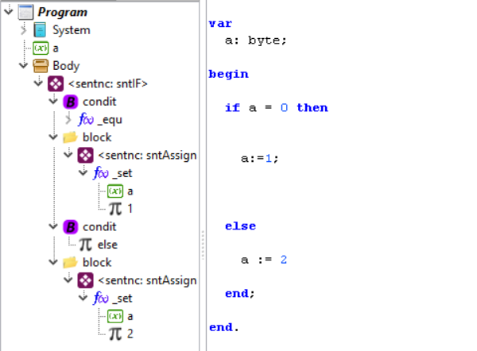

Here you can notice the internal structure of the conditions and blocks of code. Simple conditions contain only one expression, as shown in the figure, but under complex expression conditions, optimization routines can divide the expression into various expressions that are compiled as if they were separate instructions (See Optimization section of the document "Documentation – Optimization and Synthesis.docm"). When this happens, the expression that controls the condition will always be the last.

Blocks of code behave similarly to the body of a subroutine, that is, they work as statement containers. These sentences, in addition, can be of different types.

It can also be noted that the condition that represents the ELSE, contains only one expression that is of constant type, and that must have the value TRUE.

The structure of conditional statements may seem somewhat complex, but it has been designed in this way to facilitate optimization and code generation tasks.

ASSEMBLY BLOCKS

Assembler blocks, or ASM blocks, are a special type of statements that represent a common assembly block, defined by ASM delimiters... END:

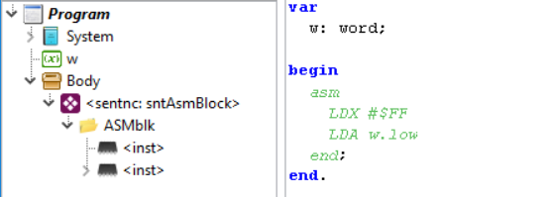

The assembly blocks are processed by the "ParserASM_6502" unit. Here are the analysis routines. The code generation routines are located in the GenCodBas_PIC16 unit.

This documentation describes the analysis process. Code generation is described in the document "Documentation – Optimization and Synthesis".

The assembly blocks generate, in the AST, an element called "ASMblk" that internally contains various elements representing the instructions.

The "ASMblk" element is the assembly block, which is modeled with the TEleAsmBlock class and behaves like an ASM instruction container. Each statement within a TEleAsmBlock represents an object of the TEleAsmInstr class.

Lexical analyzer

Even though ASM blocks are part of the programming language syntax. The "lexer" that parses the Pascal source code (TContext object), does not directly recognize the syntax of the assembler.

Therefore, the ease of the TContext lexer is used to change its token identification routine and be able to "teach" it another syntax. This change can be seen in the TParserAsm_6502.ProcessASMblock() routine of the ParserASM_6502 unit:

procedure TParserAsm_6502.ProcessASMblock(cpx0: TCompilerBase);
...
begin
cpx := cpx0; //Reference to compiler.
cpx. Next; //Get ASM
cpx.curCtx.OnDecodeNext := @DecodeNext; //Set a new lexer
StartASM;
asmBlock := TEleAsmBlock.Create;
asmBlock.srcDec := cpx. GetSrcPos;
asmBlock. name := 'ASMblk';
cpx. TreeElems.AddElementAndOpen(asmBlock);
...
//Curren token is delimiter END.
cpx.curCtx.OnDecodeNext := nil; //Restore lexer here, in order to take the "END" with the new lexer and avoid problems of syntax.
cpx. Next; //Take END with default lexer.
cpx. TreeElems.CloseElement; //Close ASM block
end;

The way to change the "scanner" of the lexical analyzer is by using the "OnDecodeNext" event. In this way we can define our custom "scanner", which recognizes the syntax of the assembler.

In our case, we set the routine TParserAsm_6502.DecodeNext() for the recognition of the new tokens. This routine must follow the rules defined for customizing the lexical analyzer.

Although we define new rules for token identification, the token types are the same as those defined in the LexPas unit.

Types of ASM Instructions

The TEleAsmInstr class, which models the assembly instructions of the 6502, has the following definition:

TEleAsmInstr = class(TxpElement)
addr : integer; //Starting Address. Used only in code generation.
iType : TiType; //ASM instruction type
//Fields to generate instructions.
opcode : word;
addMode: byte;
operVal: integer;
operRef: TxpElement;
operNam: string;
constructor Create; override;
end;

With these fields it should be possible to represent all ASM instructions, except for instructions with element operands (See section 12.3.1).

The "addr" attribute indicates the physical address of the ASM statement. In the analysis, only -1 is initialized. It will be used in code generation.

The "iType" field defines the type of the assembly statement. It is defined by the listed TiType:

TiType = (
itOpcode, //Common instruction with an Opcode and Operand.
itLabel, //An ASM label.
itOrgDir, Instrcution ORG
itDefByte //Instruction DB
);

Depending on the value of "iType" the following fields of TEleAsmInstr, will take on a special meaning.

The "itOPcode" type is the common type of assembly instructions.

The "itLabel" type identifies the tags, which here are treated as just another instruction.

The type "itOrgDir" represents an "ORG <address>" directive.

The type "itDEfByte" represents a DB directive that is used to define a simple byte.

Not all of these types are implemented in the current version of the compiler, as can be seen in TGenCodBas.GenCodeSentences(), for the case "sntAsmBlock".

The various types of implemented instructions are described below.

Common Instructions

They are identified when "iType" equals "itOpcode". This is the case for common instructions that include an Opcode, an address, and optionally an Operand, as in the following examples:

LDA $A0, X
LDX valor
BEQ jump
CLC

Common instructions can, in turn, have different types of operands depending on the value that is put in TEleAsmInstr.operVal.

Value of "operVal" | Type of Operand
>=0 | Operating direct. It reads from "OperVal".
= -1 | Operating element.
= -2 | Trading "$"

Direct operands

An operand is said to be direct when it is a literal and the value of the operand can be read directly in the same analysis phase. Some examples are:

LDA $1234
ADC #15

In this type of instructions, the fields "opcode", "addMode" and "operVal" of TEleAsmInstr are used:

TEleAsmInstr = class(TxpElement)
addr : integer; //Starting Address. Used only in code generation.
iType : TiType; //ASM instruction type
//Fields to generate instructions.
opcode : word;
addMode: byte;
operVal: integer;
...
end;

Formally the "opcode" field should be of type TP6502Inst, but it has been defined as a number, because you do not want to depend on the P6502Utils unit, in the XpresElemP65 unit, where this class is defined. This drive should be as independent as possible from the target CPU hardware.

Under normal conditions "opcode" is a positive value that is converted to a TP6502Inst, by a simple "casting", so that it identifies an OpCode of the CPU.

The "addMode" field represents the addressing mode of the statement. It is also defined as a number, for the same reason that justifies defining "opcode" as a number. It is converted to the addressing identifier, using a simple casting with TP6502AddMode().

The "operVal" field would be the value of the operand, of the ASM statement defined by "opcode" and "addMode".

In simple instructions such as: "LDA #ff" or "JSR $1234" or "BNE $FE", save the numerical value of the operand, as a positive number.

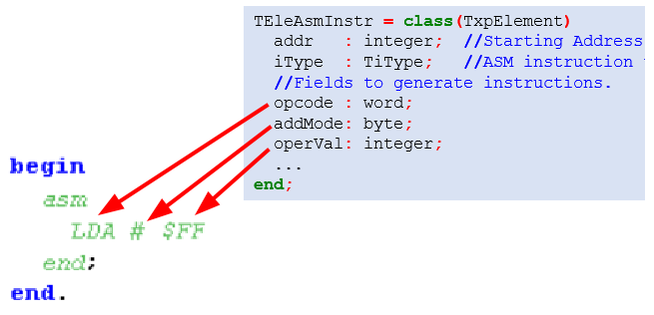

In these cases, the value of "operVal" can be solved in the analysis phase, but when the operand of the assembly instruction is a reference to an element of the language (such as a variable), we say that it is an "operand element", and it cannot be solved in the analysis phase, but the reference is saved, to be resolved later.

The element operands are described in section 12.3.2.

Element operands

An ASM statement with operand element is one that includes references to other elements of the Pascal program (containing the ASM block) or to tags in the same ASM block.

Examples of this type of instruction are:

LDA #const_pascal
STA var_pascal
JSR func_pascal
BNE label1

The elements that can be referenced in these instructions are:

- Pascal variables (Element "eleVarDec")
- Pascal Constants (Element "eleConsDec")
- Pascal Functions (Element "eleFunc")
- Tags of the same ASM block (Element "eleAsmInstr").

For this type of expression, with operands that cannot fully define the "operVal" field, the value of "operVal" is set to -1 and "operRef" is used to point to the referenced element.

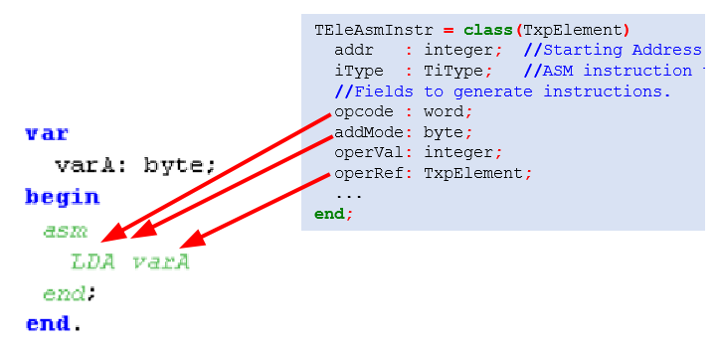

Label operands

There is a case where the operand of the statement does not refer to an element of the Pascal code, but refers to a tag of the same ASM block.

This would be the case for instructions such as:

BNE salto
JSR subrutina

These instructions are encoded by also creating an Operand on the instruction.

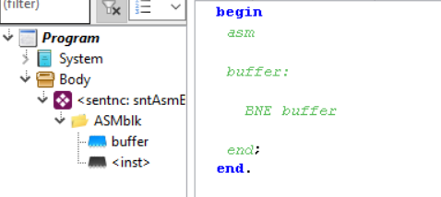
This case is handled as another case of operating element, with the exception that the referenced element is an element of the same ASM block.

Note that the buffer tag is also represented as a TEleAsmInstr instruction (See section 12.4).

These types of operands are recognized in TParserAsm_6502. CaptureOperand() and can be of two types:

- Operands already defined
- Operands to be defined

OPERANDS ALREADY DEFINED

The operands already defined are labels that are declared before they are referenced, as in the following case:

jump:
BNE salto

This case is easy to process because the label is created before it is used. This tag is assigned directly in "operRef", as seen in TParserAsm_6502. CaptureOperand():

function TParserAsm_6502. CaptureOperand: boolean;
...
begin
...
end else if cpx.tokType = tkIdentifier then begin
if IsLabelDeclared(cpx.token, lblEle) then begin
Is a tag identifier
curInst.operVal := -1; //Indicates to use "operRef"
curInst.operRef := lblEle; //Label reference.
cpx. Next;
exit(true);
end;
...
end;

OPERANDS TO BE DEFINED

Operands to be defined are tags that appear after they are referenced, as in the following case:

JMP salto
jump:

This situation raises the problem that you cannot define what the referenced tag element is, because this tag will appear (should) later.

The section of the code, which identifies undefined tag operands, is the one shown:

function TParserAsm_6502. CaptureOperand: boolean;
...
begin
...
end else if cpx.tokType = tkIdentifier then begin
...
it := cpx. TreeElems.FindFirst(cpx.token); //identifies element
if ele=nil then begin
Unidentified identifier (such as a label). It can then be defined.
curInst.operVal := -1; //Indicates to use "operRef"
curInst.operRef := nil; //Will be later linked.
curInst.operNam := UpCase(cpx.token); //Keep name to find reference.
Indefinite jumps are saved in the "undJumps" list
curBlock. undefInstrucs. Add(curInst);
cpx. Next;
exit(true);
end else begin
A language element is identified
...
end;
...
end;

For this case, the value of "operRef" is set to NIL and the "operNam" field is used to store the name of the tag that will be searched for later, when the reference is completed in the routine TParserAsm_6502.EndASM().

To know that this reference must be completed later, it is added to the list "curBlock.undefInstrucs". This list will be used in TParserAsm_6502.EndASM().

But, in addition, "curBlock.undefInstrucs" will be used in the code generation process. That is why it has been declared as part of the ASM block "curBlock" (of the TEleAsmBlock class), because that way, the list will reach the code generator.

Trading "$"

The operand "$" is the one used to refer to the current position.

This would be the case for instructions such as:

LDA $

This case is identified by putting "operVal" at -2.

Operations

Operations are understood as arithmetic or logical transformations to be applied on an operand.

Operations are created within the AST as child nodes:

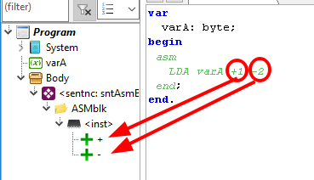

Operations are modeled with the TEleAsmOperat class:

TEleAsmOperat= class(TxpElement)
operation: TAsmInstOperation; //Operation
value : word; //Value
constructor Create; override;
end;

The implemented operations, values of the enumerated TAsmInstOperation, are small but sufficient for acceptable assembly instruction support:

TAsmInstOperation = (
aopSelByte, //Select a byte (.low, .high, >, <)
aopAddValue, //Adds a value
aopSubValue Subtract a value
);

Each operation is complemented by a number that is saved in TEleAsmOperat.value.

The expressions that can be achieved with this format are simple, but they cover most cases very well.

Operations are applied to the operand defined in "TEleAsmInstr.operVal" or in "TEleAsmInstr.operRef" and can be zero or many operations:

For example, you can model the statement well: LDA $+16-3 or LDA dato.low

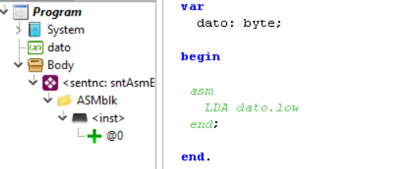

In this case, the operation "dato.low" (equivalent to "<data") is modeled as a child node with the tag "@0".

More complex parameters will mean that more operations are generated, as in the case of LDA dato.high + 2:

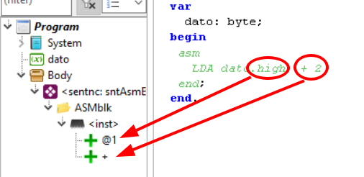

It is convenient to have represented in this way the instructions that make references to variables, functions or even declared constants, because as we are in the analysis phase, the directions of the variables or functions are not yet resolved.

Note that expressions, which will be processed in this way, do not obey criteria of precedence, but simply the order in which they are written in the instruction (from left to right).

Label Instructions

These types of instructions are identified when the "TEleAsmInstr.iType" field takes the value "itLabel".

The labels of the ASM statements are also modeled as if they were independent instructions, as an object of the TEleAsmInstr class.

For example, the following label declaration:

label1:

It will generate an "itLabel" statement. The tag name will be saved in "TEleAsmInstr.name", which is a legacy attribute.

Labels, which are included in the same line as an instruction, are also considered as separate instructions. Let's consider the case:

label1: LDA #00

This assembly line will generate two instructions, one for the label and one for the instruction, as shown in the following figure:

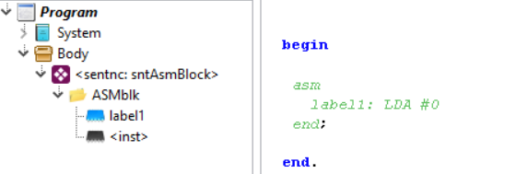

Unlike common instructions, label-statements are created with the TParserAsm_6502.AddInstructionLabel() function:

procedure TParserAsm_6502.AddInstructionLabel(lblName: string; srcDec: TSrcPos);
begin
...
curInst := TEleAsmInstr.Create;
curInst. name := lblName;
curInst.srcDec := srcDec;
cpx. TreeElems.AddElementAndOpen(curInst);
curInst.inst := -1; //Mark as jump instruction.
curInst.addr := -1; //Indicates that the physical address has not yet been fixed.
labels.add(curInst); //Add to tag list
end;

A detail about the label instructions is that they are created with the "addr" field in -1, to indicate that the label is not yet mapped in RAM. This is important because code generation routines need to know when a tag is already defined or not.

All the labels are registered in the "labels" list and then do a scan in search of references to complete. This scan is performed in TParserAsm_6502.EndASM():

procedure TParserAsm_6502.EndASM; //Asm code processing ends
...
where
jmpInst : TEleAsmInstr;
begin
Complete indefinite jumps
for jmpInst in curBlock.uncInstrucs do begin
if not CompleteUndefJump(jmpInst) then begin
There is no "jmpInst" in "labels".
cpx. GenError(ER_UNDEF_LABEL_, [jmpInst. name], jmpInst.srcDec);
end;
end;
end;

ORG Board

This type of directive is identified when the "TEleAsmInstr.iType" field takes the value "itOrgDir".

The ORG directive is also modeled as instructions, that is, as objects of the TEleAsmInstr class.

An example of an ORG directive is:

ORG $

The ORG directive allows you to define the memory position from which the assembly of the following instructions will start.

Within the AST, they appear as normal instructions with the name ORG:
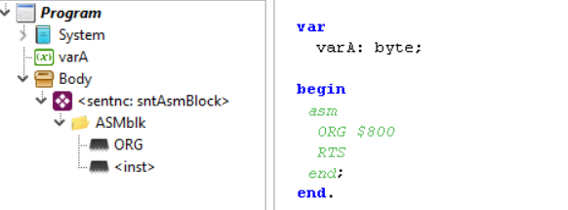

There can be many ORG directives and appear in any position, but it is clear that by their nature, they can break the order of the normal sequence of execution and could cause errors at run time if not properly controlled.

The ORG board also accepts operations on the operand:

ORG $-2

DB Policy

This type of policy is identified when the "TEleAsmInstr.iType" field takes the value "itDefByte".

The DB directive is also modeled as statements, that is, as objects of the TEleAsmInstr class.

An example of a DB policy is:

DB $12

The DB policy allows you to define values to place directly in the current position of the assembly.

Inside the AST, they appear as normal instructions with the name DB:

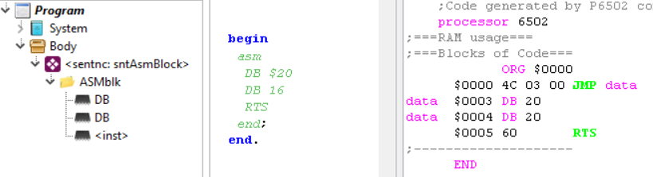

The DB directive can be used to define variables within the code section. However, for this, it is advisable to insert a jump before until after DB

JMP code
datum:
DB 0 ;d ato
Code:
LDA given

This way of working was used in earlier versions of the compiler and considerably simplified the compilation process, but since the same expression evaluator was used as for compilation, it was necessary to include code generator routines in the analysis process, which went against properly separating the analysis process from the synthesis process.
In previous versions, the value $02 was used to facilitate operations with bit 1 of the SR register. Having both bits have the same position, some operations were simplified.
These values are usually stored in internal CPU registers or in temporary variables, as explained in the document "Documentation – Optimization and Synthesis". Sometimes, they can also return constant values, but in both cases the goal is just reading.
This operator is not implemented in the current version of the compiler.
They could also return constant values, when the array and index are constant as well.
In addition to the main syntax tree, P65Pas implements an additional syntax tree for policy processing.
This rule could change if the declaration "PROGRAM..." generate an item that appears in the AST.
Of course, it can also be added simply by using AddElement() with the exception of then executing the instruction: nodo_agregado.elements := TxpElements.Create(true); for crear your list of child items.
Not currently implemented.
That is, it is only applicable to the procedure nodes and the main node.

